**Dwellingup Primary School**

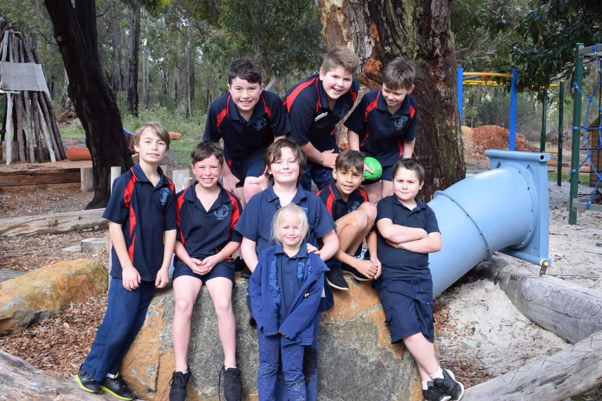

**2017 Annual Report**

 ***Dwellingup Primary School***

**ANNUAL REPORT 2017**

***From the Principal:***

It is with great pride and pleasure that I present the Dwellingup Primary School Annual Report for 2017. I would like to acknowledge and thank the school staff, School Council and the P&C for their contributions to so many areas around the school in 2017.

Dwellingup is a busy school, clear evidence of which is provided in the number of quality programs available to students and the high level of development of civic responsibility through extensive community involvement.

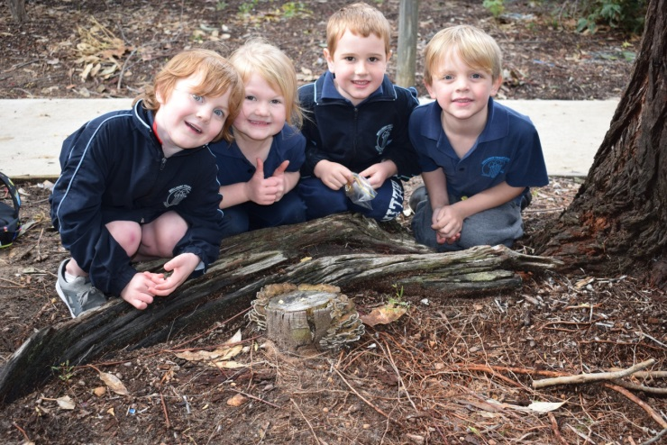In 2017 staff completed Professional Learning in addition to that completed in 2016 to implement the Western Australian Curriculum Humanities and Social Sciences and Health and Physical education curriculum. This was in place for reporting to parents in semester 1 this year.

Students at the school have the opportunity to be elected as Student Councillors. The Student Council supported the school in a range of areas. We added to student leadership opportunities by the formation of an Environmental Club.

A highlight of our school is the strong community links that enhance all aspects of our school. The annual Giant Pumpkin Competition, run by our P&C, is a major event for the town and raised over $25 000 for the school. Over 13 000 people attended on the day. We are proud that this is Dwellingup’s major event. Once again a school team participated in the 14 km event in the “Dwellingup 100” international bike event. One of our students came third in this event. The P&C caters at this event and raises substantial funds.

Our school also participates in the Seniors’ Christmas Lunch, runs the town ANZAC and Remembrance Commemorations and organises a town Mothers’ Day Morning Tea. Last year saw the relocation of the Dwellingup Community Christmas Tree to our school. Local orchardists donate fruit to our “Crunch & Sip” programme. 2017 saw the school further continuing its partnership with the Forest Heritage Centre.

Our Sustainable Schools program was enhanced by the successful application of an $8800 Wastewise grant. This will fund a mushroom growing enterprise utilising coffee grounds from local businesses. We continued our “Dirt Matters” program. This program saw students engaged in further gardening and artistic projects in the school.

The Playgroup based at the school accessed DOE’s “Transition to School” program. The Playgroup now runs two days per week. We achieved National Quality Standard Verification in all assessed areas and conducted professional learning with the other schools who have yet to receive their verification. Planning is well underway to run a school based Day Care which will support families in the area. A Chaplain is employed three days per fortnight and introduced the BUZ (Build Up Zone) programme into the school. The students enjoyed a day at the Dwellingup Trees Adventure Park as a whole school reward for their positive behaviour. Parents, staff and students all enjoyed a barbecue at the Nanga Camp site afterwards. We also enjoyed a whole school excursion / picnic to the Marrinup Falls after experiencing heavy winter rainfall. We incorporated a visit to the former Marrinup Prisoner of War Camp for older students. The year 6 students travelled to Canberra and Sydney for their camp and to provide academic extension to this targeted group.. A highlight of the visit was laying a wreath made by our local RSL and students prior to our departure at the War Memorial on Remembrance Day.

I would like to acknowledge the dedication, enthusiasm and commitment of all staff. Their ability to support each other and to work as a team is a strength of the school. It is common to see teachers here of a weekend and after school.

We are looking forward to another very productive year in 2018.

Colleen Sing

Principal

**School Ethos:**

2017 saw the continuation of our planning cycle (2016 – 2018).

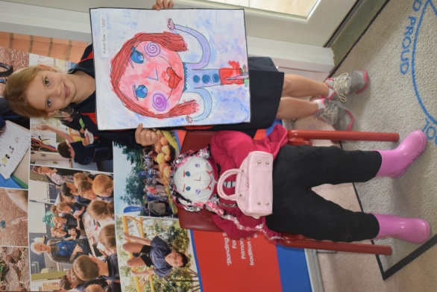Professional learning to support the School Business Plan completed by the principal and staff included data analysis training, Aboriginal Standards Cultural Standards, Six Areas of Oral Language, Jolly Grammar, 7 Steps Writing, Bushfire Education, Di Rigg Assesssment in the Early Years, Di Rigg Writing, STEAM T.D.S. Work shadowing and STEAM whole school planning. We implemented Individual Student Tracking to ensure that interventions are targeted to a greater extent. Interventions included Minilit and Multilit which has proved to be very effective. Our school motto, which underpins all that we do, is **“Standing Tall and Proud”.** This motto defines our culture of high expectations of student achievement, excellence in teaching, a safe and **caring** learning environment, community partnerships and environmental awareness.

**P – Possibilities**

**R - Respect**

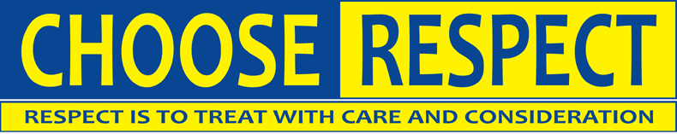**O – Opportunities**

**U – Unique**

**D – Determination**

We aim to ensure that Dwellingup Primary School is an integral part of the community, providing a focus for sustainability and developing attitudes and skills for the future.

We do this through:

• Working to understand the individual differences and needs of children.

• Inclusion of parents and community members in the life and organisation of the school.

• Continual self-evaluation and monitoring of the educational programmes that we provide.

• Inclusion of students in community events.

• Effective communication systems within the school and the wider community.

• Embedding of environmentally sustainable practices in the learning programme.

**School Vision:**

Our Dwellingup School Community provides opportunities for each child to be a lifelong learner. Skills, knowledge and values attained enable achievement in a rapidly changing world within an atmosphere of care, respect and self-worth.

**Our School and Community:**

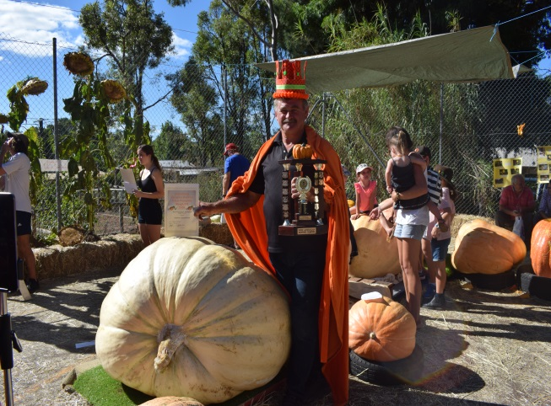 Dwellingup Primary School is located in the town of Dwellingup on the outskirts of the forests of the outer metro region of Perth. The school is 106 years old and has a tradition of high community involvement and support. The generations of families who have gone before this generation of students, are strong stakeholders in the activities of the school.

The school provides a comprehensive education for children from Kindergarten to Year 6 in a highly supportive, family focused environment in which every child counts and where every parent’s voice can be heard.

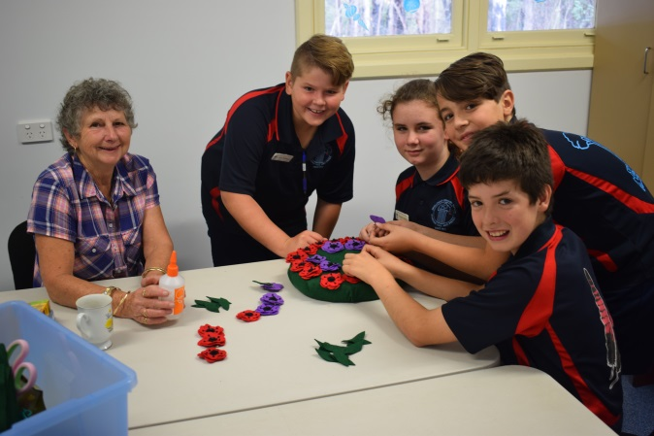Our school prides itself in being friendly and establishing meaningful relationships with the school and wider community. We aim to develop the whole child. A feature of our school is its outstanding grounds created by our W.A. Education Award winning gardener. The grounds incorporate beautiful gardens, a mini-golf course, vegetable garden and chook shed, frog pond, undercover area, Nature-Based playground and bike track. Our school is part of the Murray Waroona Schools Network. This network effectively ensures that schools in the area access relevant Professional Development and that other initiatives are implemented and supported where appropriate.

[](http://www.google.com.au/url?sa=i&rct=j&q=&esrc=s&source=images&cd=&cad=rja&uact=8&ved=0ahUKEwje8OOqgNHUAhWDQpQKHYmsCUcQjRwIBw&url=http://www.redtail.com.au/description.html&psig=AFQjCNHeY8fU6RNlPTllHEjOBcCI4xs-Cg&ust=1498205432603987) **School Council:**

In 2017 the School Council consisted of three parent representatives ~ Warren Haugh, Shani Holster, John McCooke, Anne Sinclair (community representative) and two staff representatives ~ Dawn Bosanac and Pam Laird and the principal, Colleen Sing. The School Council is a pro-active, supportive and effective group and achieved the following outcomes in 2017:

* Implementation of a new school T-shirt.
* Reviewed budget spending and allocations.
* Reviewed NAPLAN and other data.
* Decided upon and endorsed school charges and contributions for 2017.
* Endorsed the 2016 – 2018 School Plan.
* Reviewed School Policies.

**Semester Enrolments (Census dates) for 2017:**

Does not include kindergarten. Figures show Semester 2 enrolment:

|  |  |  |  |  |  |  |  |
| --- | --- | --- | --- | --- | --- | --- | --- |
|  | **2011** | **2012** | **2013** | **2014** | **\* 2015** | **2016** | **2017** |
| Enrolment Numbers | 66 | 69 | 82 | 62 | 56 | 47 | 55 |

*Numbers have declined since year 7s commenced attending secondary school in 2015.

**Transience:**

|  |  |  |  |  |  |  |  |
| --- | --- | --- | --- | --- | --- | --- | --- |
|  | **2011** | **2012** | **2013** | **2014** | **2015** | **2016** | **2017** |
| Percentage |  | 36.5% | 34.5% | 47.3% | 28.8% | 48.1% | 14.5% |

|  |
| --- |
| **ACTIONS FOR 2018**   * Continue to promote the school by placing ‘good news’ articles in newsletter and local paper. * Continue to develop the school grounds and programs within the school which increase its distinctiveness such as “Dirt Matters” in order to attract new enrolments. * The Pumpkin Festival attracts an enormous crowd and our school is promoted on “Sunrise”, state and local television and radio and social media. |

**Staff Profile:**

|  |  |  |
| --- | --- | --- |
| **STAFF 2017** | | |
| **Position** | **Numbers** | **F.T.E.** |
| **Administration Staff** | | |
| Principal | 1 | 1.0 |
| Manager Corporate Services | 1 | 1.0 |
| **Teaching Staff** | | |
| Teachers – classroom | 4 | 3.0 |
| Teacher Indonesian | 1 | 0.1 |
|  | **School Support Staff** |  |
| Education Assistants | 3 | 1.8 |
| Library Officer | 1 | 0.2 |
| Cleaning | 1 | 0.5 |
| Gardening | 1 | 0.7 |

[Description: http://stbernrdss.eq.edu.au/wp-content/uploads/Capture.png](http://www.google.com.au/url?sa=i&rct=j&q=&esrc=s&frm=1&source=images&cd=&cad=rja&uact=8&ved=0ahUKEwiBm__1w8HJAhWDKpQKHb72CxAQjRwIBw&url=http://stbernrdss.eq.edu.au/asg-national-excellence-in-teaching-awards/&psig=AFQjCNFrcnO_NF8N46-9IZbX53b_VId8EA&ust=1449295301508716)There is a full-time Manager Corporate Services and three part-time Education Assistants. A Library Officer, Gardener and Cleaner complete our small but dedicated staff.

The staff are dedicated, committed and highly proficient. The year 4/5/6 teacher is a National Excellence in Teaching recipient, the cleaner is a runner-up W.A. Support Person of the Year in the 2015 W.A. Education Awards; the gardener won the Support Person of the Year in the 2007 WA Education Awards; the K/PP teacher has Senior Teacher status; the year 1/2/3 teacher is Getting It Right Numeracy trained and a Senior Teacher and the principal has a Master of Education degree.

**Staff Professional Learning**

***Staff took part in various professional learning opportunities in 2017 to support the school and Department***

2017 saw the continuation of our planning cycle (2016 – 2018).

Professional learning to support the School Business Plan completed by the principal included data analysis training, Aboriginal Standards Cultural Standards, Six Areas of Oral Language, Jolly Grammar, 7 Steps Writing, Bushfire Education, Di Rigg Assesssment in the Early Years, Di Rigg Writing, STEAM T.D.S. Work shadowing and STEAM whole school planning. We implemented Individual Student Tracking to ensure that interventions are targeted to a greater extent. Interventions included Minilit and Multilit which has proved to be very effective.

**Student Engagement: Attendance**

Attendance has improved since 2014 and is finally above the W.A. public schools average.We aim toimprove attendance further**.** We are located 40 minutes from our nearest large town and as there is no Day-Care in town parents often take their children out of school if there are appointments that don’t coincide with school times. Absences are explained and are not due to disengagement with the education programs or other aspects of the school.

|  |  |  |
| --- | --- | --- |
|  | Attendance Rate | |
| School | WA Public Schools |
| 2013 | 91.1% | 92.6% |
| 2014 | 88.3% | 92.1% |
| 2015 | 90.3% | 92.7% |
| 2016 | 89.4% | 93.7% |
| 2017 | 93% | 92% |

|  |
| --- |
| **ACTIONS FOR 2018**   * Continue to promote parental awareness of the importance of regular attendance through newsletter articles. * Use of SIS Lesson Attendance. * Provide support via the Chaplain and School Psychologist for a students and families who require this. * Implementation of on-site Day Care. * Add attendance data to individual Student Profiles. * Publicise and reward students who attend regularly. |

**School Priorities**

Throughout the year student and school performance has been monitored through a variety of standardised tests and techniques. These include NAPLAN, On-Entry Testing (PP), Multi and Minilit data, Semester Reports and teachers’ professional judgements and observations. Due to the fact that we have small co-horts, we monitor individual student progress to a larger degree than year group improvements.

Progress in the priority areas was pleasing. Our Reading and Mathematics results were similar to or above like schools. Our Writing results were above like schools. We identified that student progress in Grammar and Punctuation from year 3 to year 5 was lower than expected. There will be more explicit teaching of grammar and punctuation with connected practice throughout the school.

The priorities for 2017 were:

* **English**
* **Mathematics**
* **HASS**
* **Science**

These priorities were supported as follows:

**English**

|  |  |  |
| --- | --- | --- |
| **Initiative** | **Funding** | **Year Levels** |
| Minilit, Multilit | $5000 grant | K-6 |
| Six Areas of Oral Language |  | K-6 |
| Di Rigg Writing |  | K-6 |
| Jolly Grammar |  | 1-6 |
| Di Rigg Dictation |  | 1-6 |
| Di Rigg language Assessment in the Early Years |  |  |

**Mathemetics**

|  |  |  |
| --- | --- | --- |
| **Initiative** | **Funding** | **Year Levels** |
| Mathletics |  | 1-6 |
| Use of Getting It Right Numeracy Teacher |  | K-6 |

**HASS**

|  |  |  |
| --- | --- | --- |
| **Initiative** | **Funding** | **Year Levels** |
| WA Curriculum Implementation |  | K-6 |

**Science**

|  |  |  |
| --- | --- | --- |
| **Initiative** | **Funding** | **Year Levels** |
| Wastewise P.D. | $8800 - Wastewise | K - 6 |
| Scitech Visit |  | K-6 |
| STEAM | TDS Teacher Relief | K-6 |

**Student Performance: On Entry**

It is mandated that all students as they enter pre-primary are tested in the On Entry testing program. Information gained from these assessments provides teachers with information about each child’s current skills and understandings to support the planning and delivery of targeted and intentional learning programs, reflective of each child’s needs and capabilities. In 2017 students were tested at the end of year 1. Their progress was compared to their progress On-Entry.

**Pre-primary** Students are expected to attain a 0.5 progression point on entry. The expectation is that PP students will have attained 1.0 progression point at the conclusion of pre-primary. It is recommended that students are not retested at the end of pre-primary unless they are deemed to be ‘at risk’. Seven students were tested. Results are as follows:

|  |  |  |  |  |  |
| --- | --- | --- | --- | --- | --- |
| **Prog. Points** | **READING** | **Prog**  **Point** | **WRITING** | **Prog.**  **Point** | **NUMERACY** |
| 0.3 | 1 | 0.1 | 7 | 0.8 | 1 |
| 0.6 | 2 |  |  | 0.9 | 1 |
| 0.7 | 1 |  |  | 1.1 | 2 |
| 0.8 | 1 |  |  | 1.2 | 1 |
| 0.9 | 1 |  |  | 1.4 | 2 |
| 1.0 | 1 |  |  |  |  |

**Year 1** students were tested at the end of the year. Students are expected to have attained 1.5 progression points. This is a small co-hort with 4 students tested. Results were as follows:

|  |  |  |  |  |  |
| --- | --- | --- | --- | --- | --- |
| **Prog. Points** | **READING** | **Prog**  **Point** | **WRITING** | **Prog.**  **Point** | **NUMERACY** |
| 0.5 | 1 | 0.0 | 1 | 1.4 | 1 |
| 1.0 | 1 | 0.4 | 1 | 1.6 | 1 |
| 1.8 | 2 | 1.3 | 1 | 1.8 | 1 |
|  |  | 2.4 | 1 | 1.9 | 2 |

**Year 1 Individual Progress**

Student 1

|  |  |  |  |
| --- | --- | --- | --- |
| **Category** | **Module 1 – On Entry** | **Module 2 – End 2017** | **Progress** |
| Reading | **0.0** | **0.5** | **0.5** |
| Writing | **0.1** | **0.0** | **-0.1** |
| Numeracy | **0.4** | **1.4** | **1.0** |

Student 2

|  |  |  |  |
| --- | --- | --- | --- |
| **Category** | **Module 1 – On Entry** | **Module 2 – End 2017** | **Progress** |
| Reading | **0.4** | **1.0** | **0.6** |
| Writing | **0.1** | **1.3** | **1.2** |
| Numeracy | **0.8** | **1.8** | **1.0** |

Student 3

|  |  |  |  |
| --- | --- | --- | --- |
| **Category** | **Module 1 – On Entry** | **Module 2 – End 2017** | **Progress** |
| Reading | **0.8** | **1.8** | **1.0** |
| Writing | **0.1** | **0.4** | **0.3** |
| Numeracy | **1.4** | **1.6** | **0.2** |

Student 4

|  |  |  |  |
| --- | --- | --- | --- |
| **Category** | **Module 1 – On Entry** | **Module 2 – End 2017** | **Progress** |
| Reading | **0.8** | **1.8** | **1.0** |
| Writing | **0.2** | **2.4** | **2.2** |
| Numeracy | **1.3** | **1.9** | **0.6** |

|  |
| --- |
| **ACTIONS FOR 2018**   * Test pre-primary students at the end of the year if “at risk” On-Entry. * Test students at the end of year 1 and for those “at risk” at the end of year 2.   (The expectation is that pre-primary will be at 1.0 progression point at the end of the year; with year 1 and year 2 students at 1.5 and 2.0 progression points respectively.)   * Students who have not attained the expected progression will receive intervention via the ‘Minilit’ (Meeting Initial Needs in Literacy) or Prelit program. |

**National Quality Standard**

The National Quality Standard (NQS) is part of the National Quality Framework and sets a national benchmark for quality education that all schools strive to meet from kindergarten to year 2. This is a continuous self-improvement model and involves staff reflecting and making adjustments to their practice. This year our school received our NQS verification in all of the quality area standards. In addition we provided professional learning for other schools in the network.

|  |  |  |  |
| --- | --- | --- | --- |
|  | **Quality Area** | **Working Towards** | **Meeting** |
| 1 | ***Educational Programs and Practice:*** *Ensuring that the educational program and practice is stimulating and engaging and enhances children’s learning and development.* |  | ✔ |
| 2 | ***Children’s Health and Safety:*** *focuses on safeguarding and* *promoting children’s health and safety.* |  | ✔ |
| 3 | ***Physical Environment:*** *focuses on the physical environment and ensuring that it is safe, suitable and provides a rich and diverse range of experiences that promote children’s learning and development.* |  | ✔ |
| 4 | ***Staffing Arrangements:*** *provision of qualified and experienced educators and principals who are able to develop warm, respectful relationships with children, create safe and predictable environments and encourage children’s active engagement in the learning program.* |  | ✔ |
| 5 | ***Relationships with Children:*** *focuses on relationships with children being responsive and respectful and promoting children’s sense of security and belonging. Relationships of this kind free children to explore the environment and engage in play and learning.* |  | ✔ |
| 6 | ***Collaborative partnerships with families and communities:*** *fundamental to achieving quality outcomes for children and community partnerships that are based on active communication, consultation and collaboration.* |  | ✔ |
| 7 | ***Leadership and Service Management:*** *positive organisational culture and building of professional learning community.* |  | ✔ |

|  |
| --- |
| **ACTIONS FOR 2018**   * 7.1.4 Year 4/5/6 teacher to attend P.L. to attain Senior Teacher status. * Continue to support schools in the Network to achieve NQS verification. |

**Student Academic Achievement**

**NATIONAL ASSESSMENT PROGRAM LITERACY & NUMERACY (NAPLAN):** All students in years 3 and 5 participated in the *National Assessment Program – Literacy & Numeracy* *(NAPLAN)* in term 2. These assessments help to identify how students are achieving and enable comparison with students across Australia. As the number of students in each year level at Dwellingup PS is small and varies considerably, analysis of overall results does not always lead to valid judgements.

The NAPLAN results have been analysed from different perspectives to enable some analysis:

1. **Comparing progress and achievement to that of like schools in terms of students performing in the top (20%), middle (60%) and bottom (20%).**

|  |
| --- |
| 1. **Comparing mean performance of the tested co-hort compared to like schools (ICSEA) and comparing progress of co-hort’s progression over time (year 3 to year 5).** |

1. **Comparing mean performance of the tested co-hort compared to like schools (ICSEA) and comparing progress of co-hort’s progression over time (year 3 to year 5).**

**1. COMPARING PROGRESS AND ACHIEVEMENT TO THAT OF LIKE SCHOOLS IN TERMS OF STUDENTS PERFORMING IN THE TOP (20%), MIDDLE (60%) AND BOTTOM (20%).**

**Figure 1: 2015 – 2017 – YEAR 3 NUMERACY PERFORMANCE COMPARED TO LIKE SCHOOLS**

|  |  |  |
| --- | --- | --- |
|  |  |  |
|  | |  |  |  |  |  |  |  |  |  | | --- | --- | --- | --- | --- | --- | --- | --- | --- | |  | **Percentages of students in top 20%, middle 60%, bottom 20% of the WA Public Schools and among Like Schools** | | | | | | |  | |  | |  | | --- | | **Year 3 Numeracy** | | | | | | | |  | |  |  |  | | --- | --- | --- | |  | **WA Public Schools** |  | | |  | | --- | | **School** | | | | |  | | --- | | **Like Schools** | | | |  | | |  | | --- | | **2015** | | |  | | --- | | **2016** | | |  | | --- | | **2017** | | |  | | --- | | **2015** | | |  | | --- | | **2016** | | |  | | --- | | **2017** | | |  | |  | | --- | | **Top 20%** | | |  | | --- | | 0% | | |  | | --- | | 0% | | |  | | --- | | 0% | | |  | | --- | | 11% | | |  | | --- | | 11% | | |  | | --- | | 13% | |  | |  | |  | | --- | | **Middle 60%** | | |  | | --- | | 33% | | |  | | --- | | 80% | | |  | | --- | | 100% | | |  | | --- | | 64% | | |  | | --- | | 59% | | |  | | --- | | 66% | |  | |  | |  | | --- | | **Bottom 20%** | | |  | | --- | | 67% | | |  | | --- | | 20% | | |  | | --- | | 0% | | |  | | --- | | 24% | | |  | | --- | | 31% | | |  | | --- | | 21% | |  | |  |  |  | | | | | |  | | | |

In 2017 there were no students in the bottom 20%, more in the middle 60% and none in the top 20%. The 2016 figures indicate 20% in the bottom 20% This variance is co-hort based.

**Figure 2: 2015 - 2017 – YEAR 5 NUMERACY PERFORMANCE COMPARED TO LIKE SCHOOLS**

|  |  |  |
| --- | --- | --- |
|  |  |  |
|  | |  |  |  |  |  |  |  |  |  | | --- | --- | --- | --- | --- | --- | --- | --- | --- | |  | **Percentages of students in top 20%, middle 60%, bottom 20% of the WA Public Schools and among Like Schools** | | | | | | |  | |  | |  | | --- | | **Year 5 Numeracy** | | | | | | | |  | |  |  |  | | --- | --- | --- | |  | **WA Public Schools** |  | | |  | | --- | | **School** | | | | |  | | --- | | **Like Schools** | | | |  | | |  | | --- | | **2015** | | |  | | --- | | **2016** | | |  | | --- | | **2017** | | |  | | --- | | **2015** | | |  | | --- | | **2016** | | |  | | --- | | **2017** | | |  | |  | | --- | | **Top 20%** | | |  | | --- | | 13% | | |  | | --- | | 33% | | |  | | --- | | 0% | | |  | | --- | | 8% | | |  | | --- | | 9% | | |  | | --- | | 12% | |  | |  | |  | | --- | | **Middle 60%** | | |  | | --- | | 88% | | |  | | --- | | 67% | | |  | | --- | | 33% | | |  | | --- | | 64% | | |  | | --- | | 59% | | |  | | --- | | 63% | |  | |  | |  | | --- | | **Bottom 20%** | | |  | | --- | | 0% | | |  | | --- | | 0% | | |  | | --- | | 67% | | |  | | --- | | 28% | | |  | | --- | | 32% | | |  | | --- | | 25% | |  | |  |  |  | | | | | |  | | | |

Figure 2 shows that in 2017 there were 67% students in the bottom 0% compared to 25% in like schools. There were 0% in the top 20% compared to 12% in like schools.

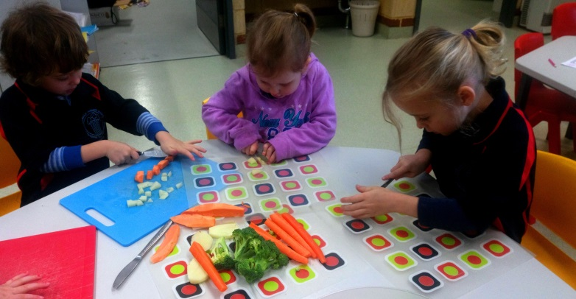

**Figure 3: 2014 – 2017 YEAR 3 READING PERFORMANCE COMPARED TO LIKE SCHOOLS**

**Percentages of students in top 20%, middle 60%, bottom 20% of the WA Public Schools and among Like Schools**

|  |  |  |  |  |  |  |  |
| --- | --- | --- | --- | --- | --- | --- | --- |
|  |  | | | | | | |
|  | |  | | --- | | **Year 3 Reading** | | | | | | |
|  | |  |  |  | | --- | --- | --- | |  | **WA Public Schools** |  | | |  | | --- | | **School** | | | | |  | | --- | | **Like Schools** | | | |
| |  | | --- | | **2015** | | |  | | --- | | **2016** | | |  | | --- | | **2017** | | |  | | --- | | **2015** | | |  | | --- | | **2016** | | |  | | --- | | **2017** | |
|  | |  | | --- | | **Top 20%** | | |  | | --- | | 0% | | |  | | --- | | 20% | | |  | | --- | | 0% | | |  | | --- | | 12% | | |  | | --- | | 12% | | |  | | --- | | 15% | |
|  | |  | | --- | | **Middle 60%** | | |  | | --- | | 100% | | |  | | --- | | 40% | | |  | | --- | | 75% | | |  | | --- | | 57% | | |  | | --- | | 62% | | |  | | --- | | 62% | |
|  | |  | | --- | | **Bottom 20%** | | |  | | --- | | 0% | | |  | | --- | | 40% | | |  | | --- | | 25% | | |  | | --- | | 31% | | |  | | --- | | 26% | | |  | | --- | | 23% | |

Figure 3 shows that in 2017 there were 25% students in the bottom 0% compared to 23% in like schools. There were more students than like schools in the middle 60% and less students than like schools in the top 20%.

**Figure 4: 2014 - 2017 YEAR 5 READING PERFORMANCE COMPARED TO LIKE SCHOOLS**

|  |  |  |  |  |  |  |  |
| --- | --- | --- | --- | --- | --- | --- | --- |
|  | **Percentages of students in top 20%, middle 60%, bottom 20% of the WA Public Schools and among Like Schools** | | | | | | |
|  | |  | | --- | | **Year 5 Reading** | | | | | | |
|  | |  |  |  | | --- | --- | --- | |  | **WA Public Schools** |  | | |  | | --- | | **School** | | | | |  | | --- | | **Like Schools** | | | |
| |  | | --- | | **2015** | | |  | | --- | | **2016** | | |  | | --- | | **2017** | | |  | | --- | | **2015** | | |  | | --- | | **2016** | | |  | | --- | | **2017** | |
|  | |  | | --- | | **Top 20%** | | |  | | --- | | 0% | | |  | | --- | | 33% | | |  | | --- | | 0% | | |  | | --- | | 10% | | |  | | --- | | 12% | | |  | | --- | | 15% | |
|  | |  | | --- | | **Middle 60%** | | |  | | --- | | 63% | | |  | | --- | | 67% | | |  | | --- | | 100% | | |  | | --- | | 65% | | |  | | --- | | 61% | | |  | | --- | | 63% | |
|  | |  | | --- | | **Bottom 20%** | | |  | | --- | | 38% | | |  | | --- | | 0% | | |  | | --- | | 0% | | |  | | --- | | 25% | | |  | | --- | | 27% | | |  | | --- | | 22% | |

Figure 4 shows that in 2017 there were no students in the bottom 20%, 100% of students in the middle 60% and no students in the top 20% compared to 15% in like schools.

**Figure 5: 2014 – 2017 YEAR 3 WRITING PERFORMANCE COMPARED TO LIKE SCHOOLS**

|  |  |  |  |  |  |  |  |
| --- | --- | --- | --- | --- | --- | --- | --- |
|  | **Percentages of students in top 20%, middle 60%, bottom 20% of the WA Public Schools and among Like Schools** | | | | | | |
|  | |  | | --- | | **Year 3 Writing** | | | | | | |
|  | |  |  |  | | --- | --- | --- | |  | **WA Public Schools** |  | | |  | | --- | | **School** | | | | |  | | --- | | **Like Schools** | | | |
| |  | | --- | | **2015** | | |  | | --- | | **2016** | | |  | | --- | | **2017** | | |  | | --- | | **2015** | | |  | | --- | | **2016** | | |  | | --- | | **2017** | |
|  | |  | | --- | | **Top 20%** | | |  | | --- | | 0% | | |  | | --- | | 0% | | |  | | --- | | 0% | | |  | | --- | | 12% | | |  | | --- | | 15% | | |  | | --- | | 17% | |
|  | |  | | --- | | **Middle 60%** | | |  | | --- | | 33% | | |  | | --- | | 80% | | |  | | --- | | 88% | | |  | | --- | | 61% | | |  | | --- | | 53% | | |  | | --- | | 63% | |
|  | |  | | --- | | **Bottom 20%** | | |  | | --- | | 67% | | |  | | --- | | 20% | | |  | | --- | | 13% | | |  | | --- | | 26% | | |  | | --- | | 32% | | |  | | --- | | 20% | |

Figure 5 shows that in 2017 there were fewer students in the bottom 20% than like schools; more students in the middle 60% than like schools and no students in the top 20% compared to 17% of students in like schools.

**Figure 6: 2014 – 2017 YEAR 5 WRITING PERFORMANCE COMPARED TO LIKE SCHOOLS**

|  |  |  |  |  |  |  |
| --- | --- | --- | --- | --- | --- | --- |
| **Percentages of students in top 20%, middle 60%, bottom 20% of the WA Public Schools and among Like Schools** | | | | | | |
|  | |  | | --- | | **Year 5 Writing** | | | | | | |
| |  |  |  | | --- | --- | --- | |  | **WA Public Schools** |  | | |  | | --- | | **School** | | | | |  | | --- | | **Like Schools** | | | |
| |  | | --- | | **2015** | | |  | | --- | | **2016** | | |  | | --- | | **2017** | | |  | | --- | | **2015** | | |  | | --- | | **2016** | | |  | | --- | | **2017** | |
| |  | | --- | | **Top 20%** | | |  | | --- | | 0% | | |  | | --- | | 67% | | |  | | --- | | 0% | | |  | | --- | | 12% | | |  | | --- | | 16% | | |  | | --- | | 14% | |
| |  | | --- | | **Middle 60%** | | |  | | --- | | 38% | | |  | | --- | | 33% | | |  | | --- | | 0% | | |  | | --- | | 62% | | |  | | --- | | 63% | | |  | | --- | | 64% | |
| |  | | --- | | **Bottom 20%** | | |  | | --- | | 63% | | |  | | --- | | 0% | | |  | | --- | | 100% | | |  | | --- | | 26% | | |  | | --- | | 21% | | |  | | --- | | 22% | |

Figure 6 shows that in 2017 100% of students were in the bottom 20% compared to 21% in like schools. One student of just 4 who sat the test refused to write anything.

**Figure 7: 2014 – 2017 YEAR 3 SPELLING PERFORMANCE COMPARED TO LIKE SCHOOLS**

|  |  |  |  |  |  |  |
| --- | --- | --- | --- | --- | --- | --- |
| **Percentages of students in top 20%, middle 60%, bottom 20% of the WA Public Schools and among Like Schools** | | | | | | |
|  | |  | | --- | | **Year 3 Spelling** | | | | | | |
| |  |  |  | | --- | --- | --- | |  | **WA Public Schools** |  | | |  | | --- | | **School** | | | | |  | | --- | | **Like Schools** | | | |
| |  | | --- | | **2015** | | |  | | --- | | **2016** | | |  | | --- | | **2017** | | |  | | --- | | **2015** | | |  | | --- | | **2016** | | |  | | --- | | **2017** | |
| |  | | --- | | **Top 20%** | | |  | | --- | | 0% | | |  | | --- | | 0% | | |  | | --- | | 0% | | |  | | --- | | 14% | | |  | | --- | | 11% | | |  | | --- | | 11% | |
| |  | | --- | | **Middle 60%** | | |  | | --- | | 33% | | |  | | --- | | 80% | | |  | | --- | | 88% | | |  | | --- | | 57% | | |  | | --- | | 63% | | |  | | --- | | 66% | |
| |  | | --- | | **Bottom 20%** | | |  | | --- | | 67% | | |  | | --- | | 20% | | |  | | --- | | 13% | | |  | | --- | | 30% | | |  | | --- | | 26% | | |  | | --- | | 23% | |

Figure 7 shows that in 2017 there were 13% of students in the bottom 20% compared to 23% in like schools; 88% in the middle 60% compared to 66% in like schools and 0% in the top 20% compared to 11% in like schools.

**Figure 8: 2014 – 2017 YEAR 5 SPELLING PERFORMANCE COMPARED TO LIKE SCHOOLS**

|  |  |  |  |  |  |  |  |
| --- | --- | --- | --- | --- | --- | --- | --- |
|  | **Percentages of students in top 20%, middle 60%, bottom 20% of the WA Public Schools and among Like Schools** | | | | | | |
|  | |  | | --- | | **Year 5 Spelling** | | | | | | |
|  | |  |  |  | | --- | --- | --- | |  | **WA Public Schools** |  | | |  | | --- | | **School** | | | | |  | | --- | | **Like Schools** | | | |
| |  | | --- | | **2015** | | |  | | --- | | **2016** | | |  | | --- | | **2017** | | |  | | --- | | **2015** | | |  | | --- | | **2016** | | |  | | --- | | **2017** | |
|  | |  | | --- | | **Top 20%** | | |  | | --- | | 0% | | |  | | --- | | 0% | | |  | | --- | | 0% | | |  | | --- | | 10% | | |  | | --- | | 12% | | |  | | --- | | 14% | |
|  | |  | | --- | | **Middle 60%** | | |  | | --- | | 50% | | |  | | --- | | 67% | | |  | | --- | | 0% | | |  | | --- | | 66% | | |  | | --- | | 58% | | |  | | --- | | 63% | |
|  | |  | | --- | | **Bottom 20%** | | |  | | --- | | 50% | | |  | | --- | | 33% | | |  | | --- | | 100% | | |  | | --- | | 24% | | |  | | --- | | 29% | | |  | | --- | | 23% | |

Figure 8 shows that there were 100% in the bottom 20% compared with 23% in like schools.

**Figure 9: 2014 – 2017 YEAR 3 GRAMMAR & PUNCTUATION PERFORMANCE COMPARED TO LIKE SCHOOLS**

|  |  |  |  |  |  |  |  |
| --- | --- | --- | --- | --- | --- | --- | --- |
|  | **Percentages of students in top 20%, middle 60%, bottom 20% of the WA Public Schools and among Like Schools** | | | | | | |
|  | |  | | --- | | **Year 3 Grammar & Punctuation** | | | | | | |
|  | |  |  |  | | --- | --- | --- | |  | **WA Public Schools** |  | | |  | | --- | | **School** | | | | |  | | --- | | **Like Schools** | | | |
| |  | | --- | | **2015** | | |  | | --- | | **2016** | | |  | | --- | | **2017** | | |  | | --- | | **2015** | | |  | | --- | | **2016** | | |  | | --- | | **2017** | |
|  | |  | | --- | | **Top 20%** | | |  | | --- | | 0% | | |  | | --- | | 20% | | |  | | --- | | 13% | | |  | | --- | | 12% | | |  | | --- | | 11% | | |  | | --- | | 14% | |
|  | |  | | --- | | **Middle 60%** | | |  | | --- | | 67% | | |  | | --- | | 60% | | |  | | --- | | 75% | | |  | | --- | | 62% | | |  | | --- | | 61% | | |  | | --- | | 61% | |
|  | |  | | --- | | **Bottom 20%** | | |  | | --- | | 33% | | |  | | --- | | 20% | | |  | | --- | | 13% | | |  | | --- | | 25% | | |  | | --- | | 28% | | |  | | --- | | 25% | |

Figure 9 shows that there were 13% in the bottom 20% compared to 25% in like schools; 675% in the middle 60% compared to 61% in like schools and 13% in the top 20% compared to 14% in like schools,

**Figure 10: 2014 – 2017 YEAR 5 GRAMMAR & PUNCTUATION PERFORMANCE COMPARED TO LIKE SCHOOL**

|  |  |  |  |  |  |  |  |
| --- | --- | --- | --- | --- | --- | --- | --- |
| **Percentages of students in top 20%, middle 60%, bottom 20% of the WA Public Schools and among Like Schools** | | | | | | |  |
|  | |  | | --- | | **Year 5 Grammar & Punctuation** | | | | | | |
| |  |  |  | | --- | --- | --- | |  | **WA Public Schools** |  | | |  | | --- | | **School** | | | | |  | | --- | | **Like Schools** | | | |  |
| |  | | --- | | **2015** | | |  | | --- | | **2016** | | |  | | --- | | **2017** | | |  | | --- | | **2015** | | |  | | --- | | **2016** | | |  | | --- | | **2017** | |
| |  | | --- | | **Top 20%** | | |  | | --- | | 0% | | |  | | --- | | 0% | | |  | | --- | | 0% | | |  | | --- | | 13% | | |  | | --- | | 11% | | |  | | --- | | 13% | |  |
| |  | | --- | | **Middle 60%** | | |  | | --- | | 38% | | |  | | --- | | 67% | | |  | | --- | | 33% | | |  | | --- | | 58% | | |  | | --- | | 66% | | |  | | --- | | 69% | |  |
| |  | | --- | | **Bottom 20%** | | |  | | --- | | 63% | | |  | | --- | | 33% | | |  | | --- | | 67% | | |  | | --- | | 29% | | |  | | --- | | 23% | | |  | | --- | | 18% | |  |

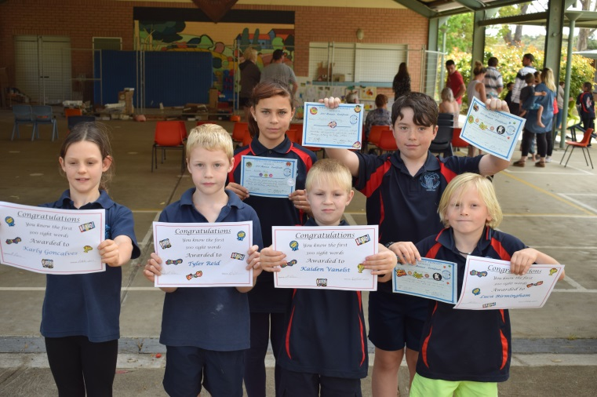Figure 10 shows that there were 67% of students in the bottom 20% compared to 18 % in like schools, 33% in the middle 60% compared to 69% in like schools and 0% in the top 20% compared to 13% in like schools.

1. **COMPARING MEAN PERFORMANCE OF TESTED CO-HORT COMPARED TO LIKE SCHOOLS (ICSEA) AND COMPARING PROGRESS OF CO-HORTS PROGRESSION OVER TIME**

**Figure 1 2013 – 2017 NUMERACY**

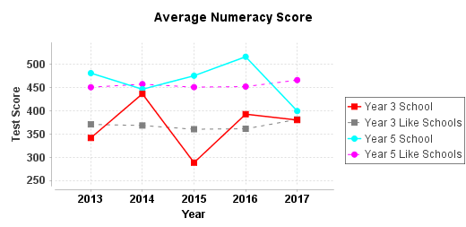

**Figure 2 2012 – 2017 NUMERACY**

Figure 1 shows that the year 3 students tested in 2015 have progressed NAPLAN points when tested in year 5 compared to 84 in like schools

**Figure 2 2013 – 2017 READING**

**NOTE: Care must be taken when interpreting all of our school results because of very low student numbers which means one student’s extremely positive or negative result can skew the mean score significantly.**

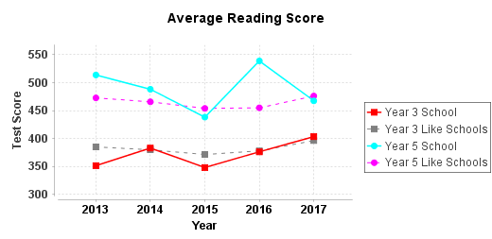

Figure 1 shows that the year 3 students tested in 2014 have progressed 158 NAPLAN points when tested in year 5 compared to 72 in like schools

|  |
| --- |
|  |

**Figure 3 2012 – 2017 WRITING**

**NOTE: Care must be taken when interpreting all of our school results because of very low student numbers which means one student’s extremely positive or negative result can skew the mean score significantly.**

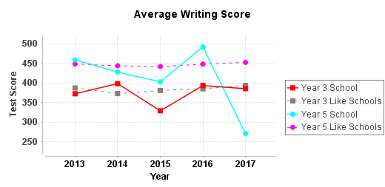

Figure 3 shows that the year 3 students tested in 2014 have progressed 100 NAPLAN points when tested in year 5 compared to 78 in like schools

**Figure 4 2012 – 2017 SPELLING**

**NOTE: Care must be taken when interpreting all of our school results because of very low student numbers which means one student’s extremely positive or negative result can skew the mean score significantly.**

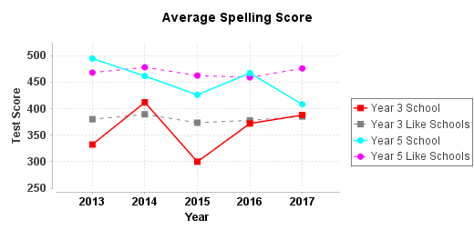

Figure 4 shows that the year 3 students tested in 2014 have progressed 160 NAPLAN points when tested in year 5 compared to 65 with that of like schools

**Figure 5 2012 – 2017 GRAMMAR AND PUNCTUATION**

**NOTE: Care must be taken when interpreting all of our school results because of very low student numbers which means one student’s extremely positive or negative result can skew the mean score significantly.**

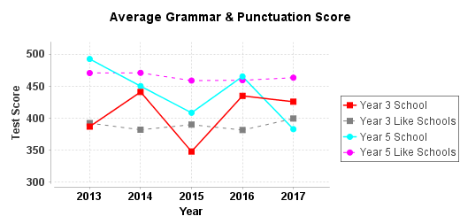

Figure 5 shows that the year 3 students tested in 2014 have progressed 30 NAPLAN points when tested in year 5 compared to 80 with that of like schools

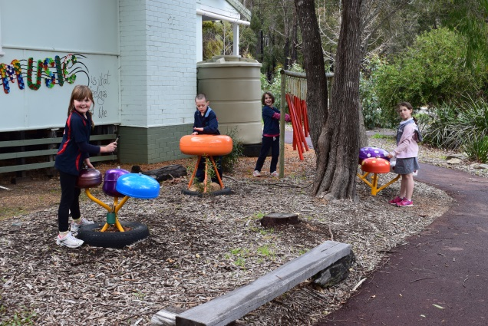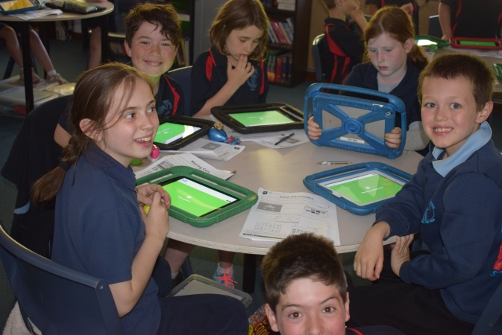

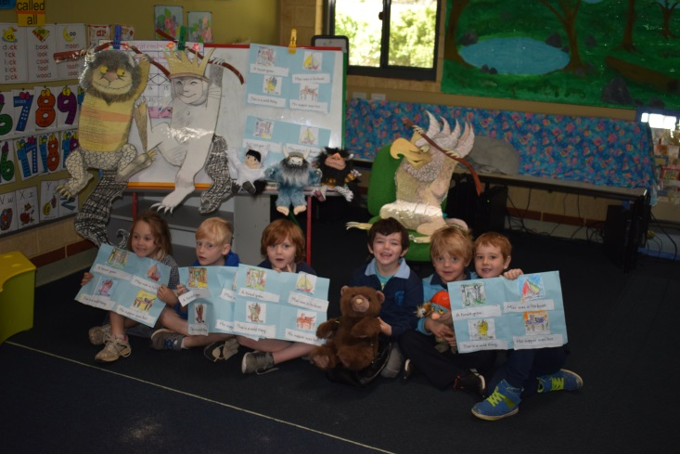

1. **COMPARING MEAN PERFORMANCE OF THE TESTED CO-HORT COMPARED TO LIKE SCHOOLS (ICSEA) AND COMPARING PROGRESS OF CO-HORT’S PROGRESSION OVER TIME (YEAR 3 TO YEAR 5)**

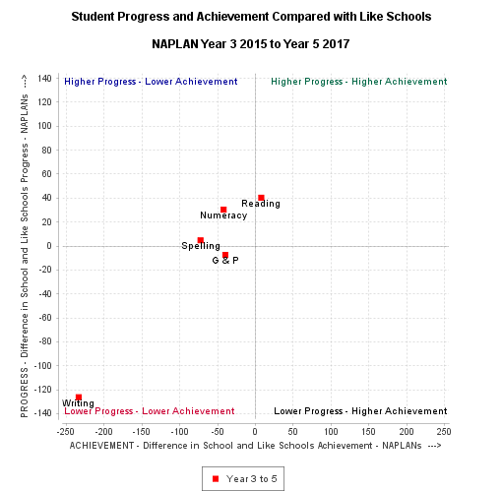

Students made pleasing progress and achievement in reading over time. Achievement was pleasing in writing, spelling and numeracy and progress average to just below average. With Grammar & Punctuation, students achieved highly but progress from year 3 was of concern.

|  |
| --- |
| **ACTIONS FOR 2018**   * **Explicit teaching of Grammar and Punctuation in years 4/5/6.** * **Use of “Multilit” programme to target students who are not progressing as expected in Spelling and Reading.** * **Implementation of individual profiles for each student to ensure more accurate tracking and targeted intervention.** * **Introduce “Daily Writing” to embed phonemic awareness and apply knowledge of grammar and punctuation.** * **Include Dictation when testing spelling.** * **Implement “Brightpath” Writing assessment.** |

Attitude Behaviour Effort

1. ***Displays independence.***
2. ***Makes positive choices with confidence.***
3. ***Reflects on and talks about own learning.***
4. ***Displays perseverance.***
5. ***Expresses emotions appropriately.***
6. ***Respects the ideas, feelings and needs of others.***
7. ***Resolves conflicts in a positive manner.***
8. ***Interacts with peers and adults in acceptable ways.***
9. ***Collaborates in group activities.***

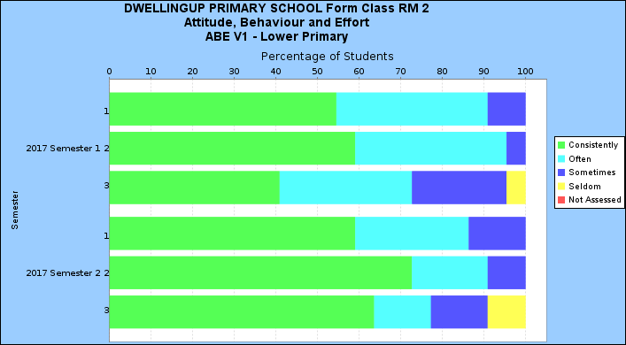

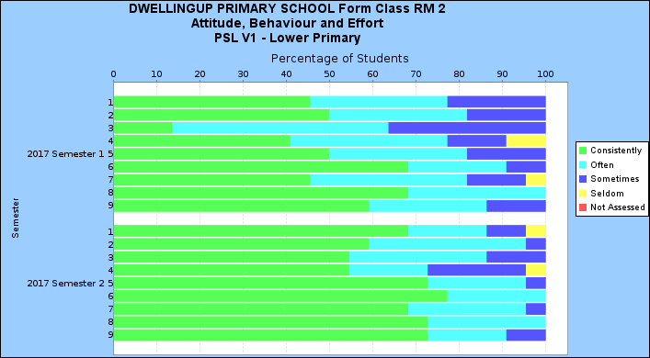

1. ***Works to the best of his / her ability.***
2. ***Shows self-respect and care.***
3. ***Shows courtesy and respect for the rights of others.***
4. ***Participates responsibly in social and civic activities.***
5. ***Cooperates productively and builds positive relationships.***
6. ***Is enthusiastic about learning.***
7. ***Sets goals and works towards them with perseverance.***
8. ***Shows confidence in making positive choices and decisions.***

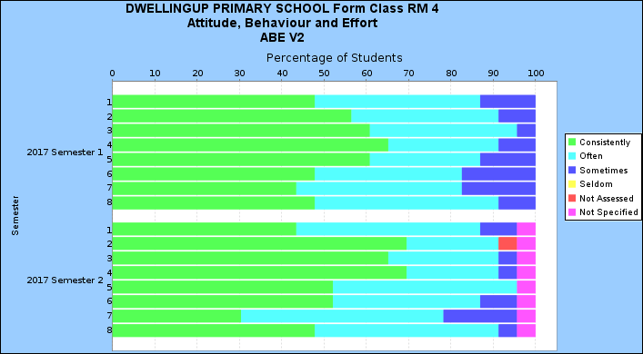

|  |
| --- |
| **ACTIONS FOR 2018**   * **In the lower primary students need to *reflect on and talk about their learning* to a greater extent. Identifying areas of weakness and setting goals to be introduced.** * ***Successful goal setting* is an issue with students in the senior years.** * **In the upper primary, there was deterioration in *setting goals and works toward them with perseverance* between semester 1 and 2. The discrepancy could be due to a change of teacher and enrolment of new students.** * **Focussing on creative and critical thinking through enquiry based activities, STEAM and environmental activities will assist with metacognition.** * **Targeted students to receive input from the Chaplain. Confidence and self-esteem are issues with some students.** * **Whole class strategies to be implemented by Chaplain to support this area.** * **Provision of extension activities for talented students and use of interventions such as “Minilit” and “Multilit” will support student engagement.** |

Value Adding

Special programmes are in place to meet the needs of individual and targeted groups of students.

* Students at Educational Risk are delivered intervention programs by way of Individual Education Plans which provide tailored additional support / extension for identified students. They may also include plans for behavioural or social issues.
* Use of ‘Multilit’ and ‘Minilit’ and ‘Prelit’ programs for targeted students.
* Participation in swimming lessons, interschool athletics carnivals, sporting clinics, cross-country running and an after school-bike club which culminated in a group participating in a 14km race at the “Dwellingup 100” event.
* A partnership with the Forest Heritage Centre ~ Arts and Environmental activities.
* Chaplaincy programme ~ BUZ (Build Up Zone) bully proofing programme.
* Virtues programme.
* ‘Choose Respect’ programme.
* Whole School Reward Day ~ Trees Adventure
* Scitech maths extension programme.

|  |
| --- |
| **ACTIONS FOR 2018**   * Collaborate with Coolbinia TDS to develop an enquiry based cross curricular investigation “Trails” in the school with the ultimate aim of regenerating Bushland at the back of the school. |

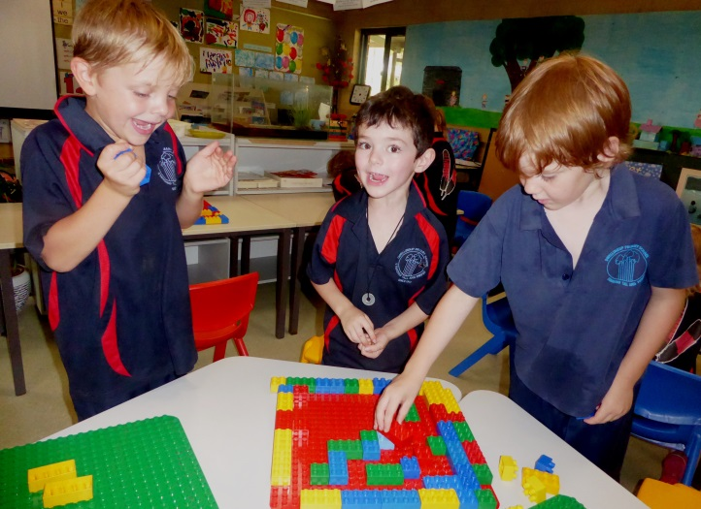

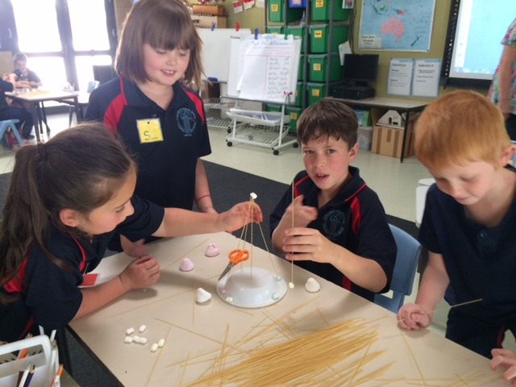

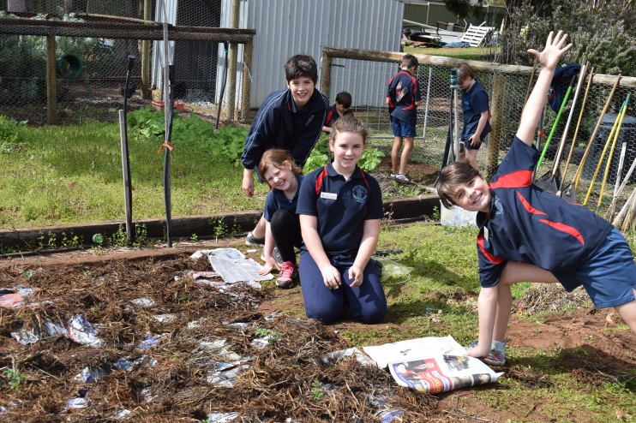

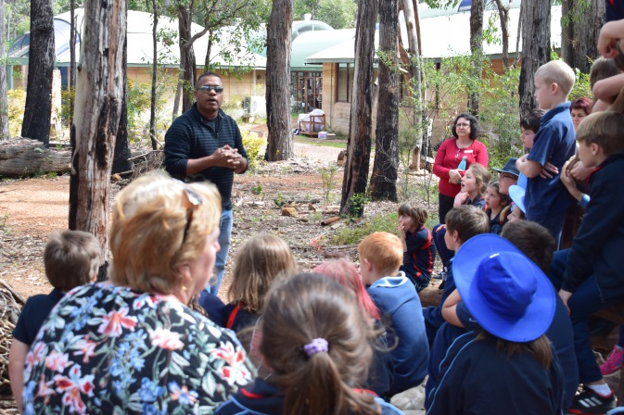Aboriginal Cultural Standard

The Aboriginal Cultural Standard, released this year, sets expected standards for schools when working with Aboriginal students, their families and communities. It also guides us to incorporate culturally responsive attitudes, values and behaviours into our everyday work. The principal has received professional learning in all aspects of the Framework and its implementation.

|  |
| --- |
| **ACTIONS FOR 2018**   * Continue to incorporate Aboriginal culture, perspectives and history across curriculum areas. * Continue to involve local Aboriginal people in student learning. * Include Six Aboriginal Seasons in newsletter. * Introduce “Welcome to Country” at assemblies. * Create Aboriginal themed garden at front of school funded by PALS grant. |

National School Opinion Survey - Parents

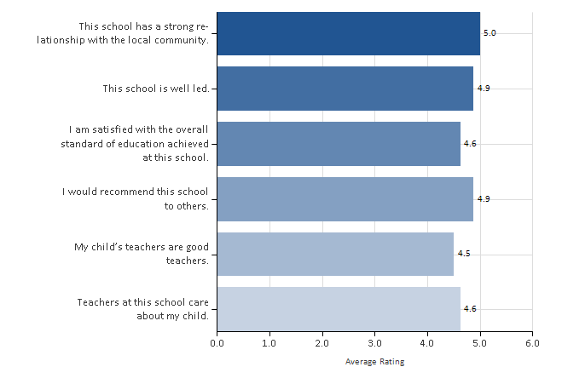

|  |  |
| --- | --- |
| **Rating** | **Score** |
| Strongly agree | 5 |
| Agree | 4 |
| Neither agree nor disagree | 3 |
| Disagree | 2 |
| Strongly disagree | 1 |

National School Opinion Survey - Staff

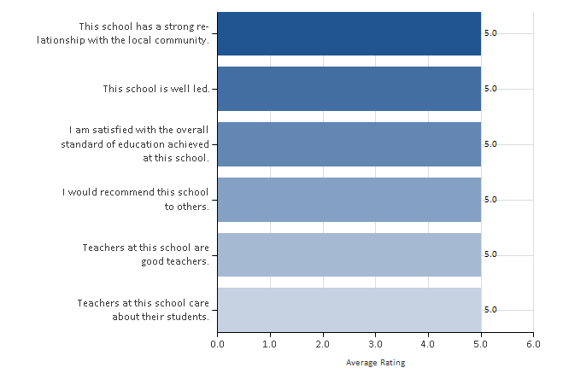

National School Opinion Survey - Students

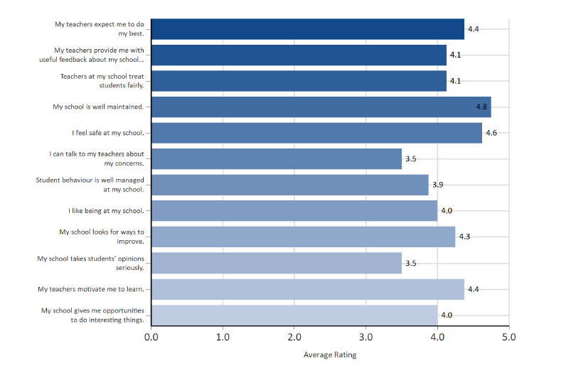

**Highlights of 2017:**

**February**

Welcome Morning Tea ~ we welcomed new parents to the school and Playgroup with a morning tea.

**March**

On –Entry Assessment Program Information is collected on every pre-primary child to ensure that teaching is informed and intentional and relative interventions can be put in place if needed.

Forest Heritage Centre Excursion

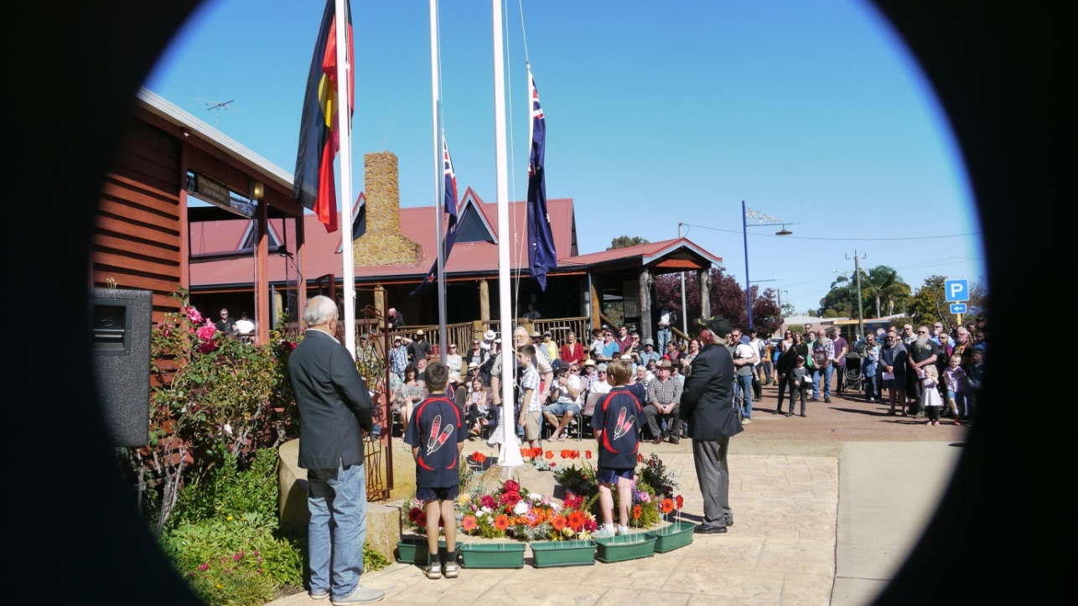Student Councillors Elected

National “Ride to School Day” and Whole School Breakfast

Year 4/5/6 “Sculpture by the Sea” Excursion

Noise Awareness Workshop yrs 4/5/6

“Wear Red for Firies” Day

**April**

ANZAC Commemoration R & S L Hall

Giant Pumpkin Festival ~ Our P&C organises this major event in our town. $15 000 was raised for our school and over 5000 people attended.

**May**

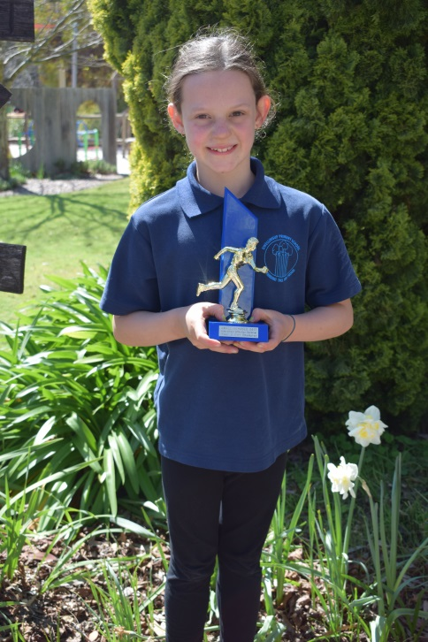Mothers’ Day Morning Tea Organised by the school for all mothers in the community. Students attend the hall to entertain.

Bookweek Book Character Dress Up

**June**

Interschool Cross Country

Dress as a Pirate Day - Student Council fundraiser.

**July**

“100 days at School” maths event

**August**

Faction Sports

Peel Language Development School Speech and Language ~ Kindy Café for parents.

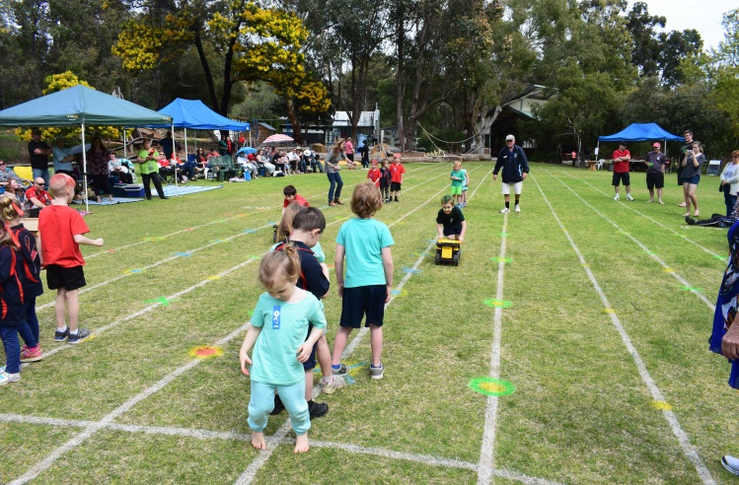**September**

“Dwellingup 100” Bike Ride

Faction Sports

Interschool Sports

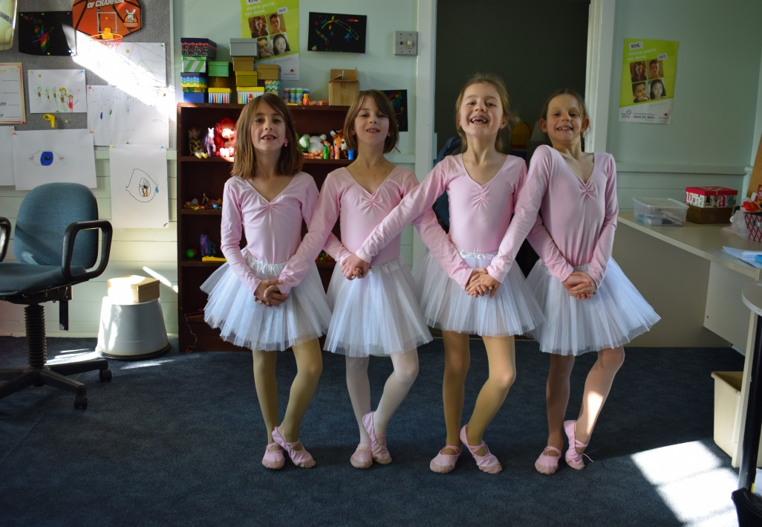Innovation Work Shadowing Day at Coolbinia Primary School

**October**

Trees Adventure – Whole School reward

Swimming Lessons PP-6

**November**

Canberra Camp Yrs 4/5/6

Growth & Development year 6

Remembrance Day

Kindy Transition

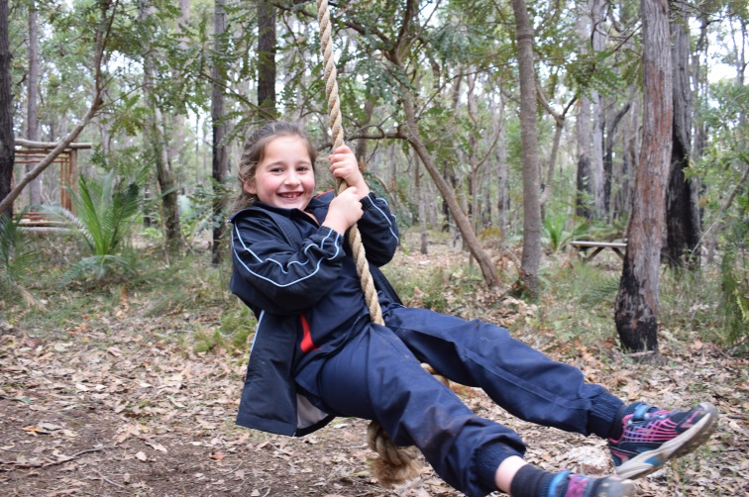**December**

Seniors’ Christmas Lunch Students perform in the hall for the senior Dwellingup residents.

Kindy Orientation Day

Presentation / Graduation Night

Yr 6 Graduation Dinner

Fire Brigade “Hose Down” on Last Day.

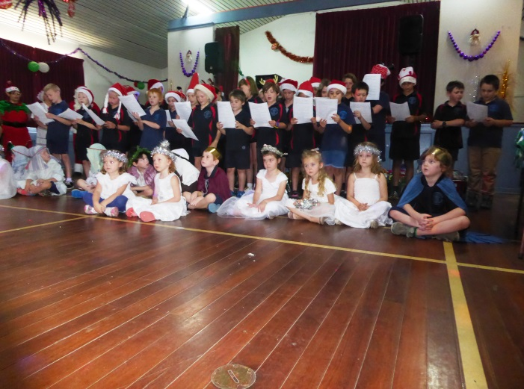 We continued our community involvement literally to the very last minute of school. Getting a good drenching by our local Volunteer Fire Brigade on the last fifteen minutes before the holidays has become a Dwellingup Primary School tradition. Thank you for all of the good work that our volunteer ‘firies’ do in our community.

**Summary 2017:**

The Department of Education’s Strategic Plan for WA Public Schools 2016 – 2019 is titled “**High Performance – High Care”.**  This plan prioritises DOE’s work over the next four years. These are Dwellingup Primary School’s priorities for 2016 – 2018.

|  |  |
| --- | --- |
| **FOCUS AREA** | **PRIORITIES FOR 2018 AND BEYOND** |
| **HIGH PERFORMANCE** | * Continue WA Curriculum implementation as mandated by SCSA (School Curriculum and Standrads Authority). * Intervene early with students at educational risk by utilising Pre-Lit, Minilit and Multilit as well as other direct instruction tools such as Di Rigg strategies. * Introduce individual Student Profiles to track student progress over time. * Regularly monitor student progress and make adjustments and interventions where necessary. * Continue to meet the requirements of the National Quality Standard. * The Performance Management process is linked to the AITSL (Australian Institute for Teaching and School Leadership) standards and is aligned to school priorirties and student needs. * Implement additional whole school approaches to the teaching of literacy and numeracy. * Focus on explicit teaching of Grammar in the senior years and Writing across the whole school. * Implement “Brightpath” Writing assessment. |
| **HIGH CARE** | * The “Choose Respect” focus underpins everyone’s actions. * Provide increased student laedership opportunities by the introduction of a “Sustainable Schools” group. * Continue to reward positive behaviour and work ethic by “Marble in Jar” meetings and whole school rewards. * Continue to promote a positive school culture through engagement with the community. * Continue to hold high expectations for students and positive relationships with parents, staff, students and the community. * Continued involvement in the Chaplaincy programme. * Use of the Virtues programme throughout the school. |
| **SUSTAINABLE SCHOOLS PROGRAM** | * Continuation of the “Dirt Matters” program with students in years K/PP and years 4/5/6. Implement program to students in years 1/2/3. Include enquiry based components through involvement with Coolbinia TDS. * Expenditure of a $8000 Wastewise Grant to expand the Sustainable Schools programme. * Increase the amount of recycling in the school. * Apply for a grant to purchase interactive on-line materials to be used with Science Primary Connections. * Scitech visit. |
| **COMMUNITY AND CIVICS** | * Continued involvement in community events. * Continue partnerships with Alcoa, Forest Heritage Centre, Newmont and other organisations who support us. * Giant Pumpkin Festival. |



We, the members of the Dwellingup Primary

School Council do hereby endorse

the Dwellingup Primary School 2017 Annual Report

______________________ Dawn Bosanac (School Representative)

______________________ Shani Holster (Parent Representative)

______________________ Pamela Laird (School Representative)

______________________ John McCooke (Parent Representaive)

**______________________** Warren Haugh (P&C, Parent Representative)

______________________ Anne Sinclair (Community Representative)

______________________ Colleen Sing (Principal)