**ASSESSMENT & REPORTING TO PARENTS GUIDELINES**

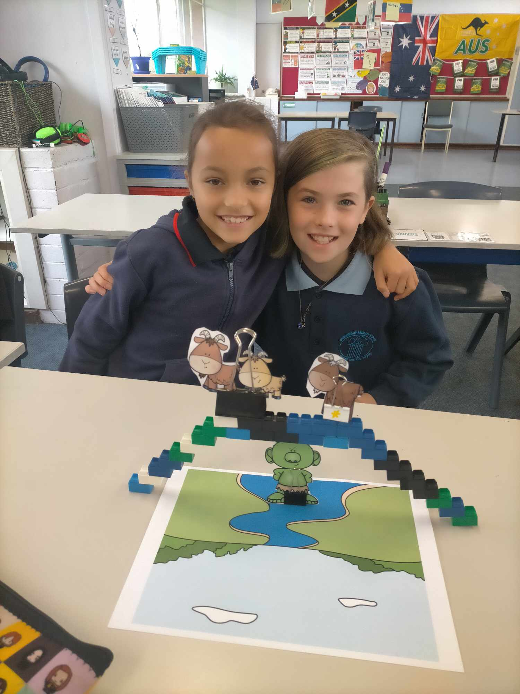

Overview

Dwellingup Primary School communicates with parents and carers throughout the year to ensure that they are well informed about their child’s achievement and progress.

Every student receives two formal end of semester reports per year. Further, Pre-primary students are given a document detailing their On Entry Assessment results in first semester and Year 3 and 5 students receive NAPLAN reports detailing achievement in Spelling, Grammar & Punctuation, Reading, Writing and Numeracy. All students at a ‘D’ or below and all students achieving an ‘A’ in English and/or Mathematics must be reported against their SEN IEP using SEN reporting in addition to the standard report.

In addition to these formal documents, teachers report informally throughout the year in a variety of ways including meetings, notes and phone conversations. These methods ensure that formal reports hold no surprises for parents and carers.

Reference and Resources

Assessment - <http://k10outline.scsa.wa.edu.au/home/assessment/principles-and-reflective-questions>

Judging Standards - <http://k10outline.scsa.wa.edu.au/home/judging-standards>

Reporting - <http://k10outline.scsa.wa.edu.au/home/reporting>

**ASSESSMENT:**

Assessment is the process of gathering information about student learning and making judgements on achievement using the gathered data. At Dwellingup PS, this information is collected in a variety of ways in accordance with SCSA’s Assessment Principles. (SCSA - School Curriculum and Standards Authority)

1. Assessment should be an integral part of Teaching and Learning.
2. Assessment should be educative.
3. Assessment should be fair.
4. Assessment should be designed to meet its specific purpose.
5. Assessment should lead to informative reporting.
6. Assessment should lead to school-wide evaluation processes.

At Dwellingup PS, teachers engage in moderation within the school, the Murray network and use SCSA’s Judging Tool to report against the Achievement Standards and ensure consistency.

Table of Assessments used at Dwellingup PS

|  |  |  |  |  |  |  |  |  |  |  |  |  |  |  |  |  |  |  |  |  |  |  |  |  |  |  |  |  |  |  |  |  |  |  |  |  |  |  |  |  |  |  |  |  |  |  |  |  |  |  |  |  |  |  |  |  |  |  |  |  |  |  |  |  |  |  |  |  |  |  |  |  |  |  |  |  |  |  |  |  |  |  |  |  |  |  |  |  |  |  |  |
| --- | --- | --- | --- | --- | --- | --- | --- | --- | --- | --- | --- | --- | --- | --- | --- | --- | --- | --- | --- | --- | --- | --- | --- | --- | --- | --- | --- | --- | --- | --- | --- | --- | --- | --- | --- | --- | --- | --- | --- | --- | --- | --- | --- | --- | --- | --- | --- | --- | --- | --- | --- | --- | --- | --- | --- | --- | --- | --- | --- | --- | --- | --- | --- | --- | --- | --- | --- | --- | --- | --- | --- | --- | --- | --- | --- | --- | --- | --- | --- | --- | --- | --- | --- | --- | --- | --- | --- | --- | --- | --- | --- |
| **STUDENT ACHIEVEMENT & PROGRESS** | | | | | | | | | | | | | | | | | | | | | | | | | | | | | | | | | | | | | | | | | | | | | | | | | | | | | | | | | | | | | | | | | | | | | | | | | | | | | | | | | | | | | | | | | | | |
| **Assessment Tool** | **Who completes the assessment?** | | | | | | | | | | | | | | | | | | | | | | | | | | | | | | | | | | | | | | | | | | **When is the assessment is conducted?** | | | | | | | | | | | | | | | | | | **When are the results analysed?** | | | | | | | | | | | | | | | | | | **When are the results reported?** | | | | | | | | | | | | |
| **K** | | | | | **P** | | | | **1** | | | | **2** | | | | **3** | | | | **4** | | | | **5** | | | | **6** | | | | **Staff** | | | | **Parents** | | | | **T1** | | | | | | **T2** | | | | **T3** | | | | **T4** | | | | **T1** | | | | | | **T2** | | | | **T3** | | | | **T4** | | | | **Staff** | | | | | | **Parents** | | | | **Council** | | | |
| RTP |  | | | | |  | | | |  | | | |  | | | |  | | | |  | | | |  | | | |  | | | |  | | | |  | | | |  | | | | | | 8 | | | |  | | | | 8 | | | |  | | | | | |  | | | |  | | | |  | | | | T1&4  W8 | | | | | | T1&4  W9 | | | |  | | | |
| Parent Interviews |  | | | | |  | | | |  | | | |  | | | |  | | | |  | | | |  | | | |  | | | |  | | | |  | | | |  | | | | | |  | | | |  | | | |  | | | |  | | | | | |  | | | |  | | | |  | | | |  | | | | | | T2 & 4 W10 | | | |  | | | |
| ABE: attitude, Behaviour, Effort |  | | | | |  | | | |  | | | |  | | | |  | | | |  | | | |  | | | |  | | | |  | | | |  | | | |  | | | | | | 8 | | | |  | | | | 8 | | | |  | | | | | |  | | | |  | | | |  | | | | T1&4  W8 | | | | | | T1&4  W9 | | | |  | | | |
| Moderation Tasks |  | | | | |  | | | |  | | | |  | | | |  | | | |  | | | |  | | | |  | | | |  | | | |  | | | | 6 | | | | | |  | | | | 6 | | | |  | | | | 6 | | | | | |  | | | | 6 | | | |  | | | | W6 | | | | | |  | | | |  | | | |
| On Entry |  | | | | |  | | | |  | | | |  | | | |  | | | |  | | | |  | | | |  | | | |  | | | |  | | | | 6 | | | | | |  | | | |  | | | | 6 | | | | 7 | | | | | |  | | | |  | | | |  | | | | T1W9 | | | | | | T1W10 | | | |  | | | |
| NAPLAN |  | | | | |  | | | |  | | | |  | | | |  | | | |  | | | |  | | | |  | | | |  | | | |  | | | | 4 | | | | | |  | | | |  | | | |  | | | |  | | | | | | 6-8 | | | |  | | | |  | | | | When available | | | | | | | | | | | | | |
| PEAC |  | | | | |  | | | |  | | | |  | | | |  | | | |  | | | |  | | | |  | | | |  | | | |  | | | |  | | | | | |  | | | | 3 | | | |  | | | |  | | | | | |  | | | |  | | | |  | | | |  | | | | | | T3W10 | | | |  | | | |
| IEP/GEP |  | | | | |  | | | |  | | | |  | | | |  | | | |  | | | |  | | | |  | | | |  | | | |  | | | | 5 | | | | | | 5 | | | | 5 | | | | 5 | | | |  | | | | | |  | | | |  | | | |  | | | |  | | | | | | W5 | | | |  | | | |
|  | | | | | | | | | | | | | | | | | | | | | | | | | | | | | | | | | | | | | | | | | | | | | | | | | | | | | | | | | | | | | | | | | | | | | | | | | | | | | | | | | | | | | | | | | | | |
| **Literacy** | | | | | | | | | | | | | | | | | | | | | | | | | | | | | | | | | | | | | | | | | | | | | | | | | | | | | | | | | | | | | | | | | | | | | | | | | | | | | | | | | | | | | | | | | | | |
| **Assessment Tool** | **Who completes the assessment?** | | | | | | | | | | | | | | | | | | | | | | | | | | | | | | | | | | | | | | | | | | **When is the assessment is conducted?** | | | | | | | | | | | | | | | | | | **When are the results analysed?** | | | | | | | | | | | | | | | | | | **When are the results reported?** | | | | | | | | | | | | |
| **K** | | | | | **P** | | | | **1** | | | | **2** | | | | **3** | | | | **4** | | | | **5** | | | | **6** | | | | **Staff** | | | | **Parents** | | | | **T1** | | | | | | **T2** | | | | **T3** | | | | **T4** | | | | **T1** | | | | | | **T2** | | | | **T3** | | | | **T4** | | | | **Staff** | | | | | | **Parents** | | | | **Council** | | | |
| PAT Reading Early Years |  | | | | |  | | | |  | | | |  | | | |  | | | |  | | | |  | | | |  | | | |  | | | |  | | | |  | | | | | | 6 | | | |  | | | | 6 | | | |  | | | | | | 8 | | | |  | | | | 8 | | | | T2 & 4 W7 | | | | | |  | | | |  | | | |
| PAT Reading Adaptive |  | | | | |  | | | |  | | | |  | | | |  | | | |  | | | |  | | | |  | | | |  | | | |  | | | |  | | | | | | 6 | | | |  | | | | 6 | | | |  | | | | | | 8 | | | |  | | | | 8 | | | | T2 & 4 W 7 | | | | | |  | | | |  | | | |
| Write Mark |  | | | | |  | | | |  | | | |  | | | |  | | | |  | | | |  | | | |  | | | |  | | | |  | | | |  | | | | | | 6 | | | |  | | | |  | | | |  | | | | | | 6 | | | |  | | | |  | | | | T2 W7 | | | | | |  | | | |  | | | |
| PAT Spelling |  | | | | |  | | | |  | | | |  | | | |  | | | |  | | | |  | | | |  | | | |  | | | |  | | | |  | | | | | |  | | | |  | | | | 6 | | | |  | | | | | | 8 | | | |  | | | | 8 | | | | T4 W 7 | | | | | |  | | | |  | | | |
| PAT Grammar & Punctuation |  | | | | |  | | | |  | | | |  | | | |  | | | |  | | | |  | | | |  | | | |  | | | |  | | | |  | | | | | |  | | | |  | | | | 6 | | | |  | | | | | | 8 | | | |  | | | | 8 | | | | T4 W 7 | | | | | |  | | | |  | | | |
| Initialit Screener |  | | | | |  | | | |  | | | |  | | | |  | | | |  | | | |  | | | |  | | | |  | | | |  | | | | 1 | | | | | |  | | | |  | | | |  | | | | 1 | | | | | |  | | | |  | | | |  | | | |  | | | | | | T1 W2 | | | |  | | | |
| Initialit Cumulative Reviews |  | | | | |  | | | |  | | | |  | | | |  | | | |  | | | |  | | | |  | | | |  | | | |  | | | | 9 | | | | | | 9 | | | | 9 | | | | 8 | | | | 10 | | | | | | 10 | | | | 10 | | | | 10 | | | |  | | | | | |  | | | |  | | | |
| WARN |  | | | | |  | | | |  | | | |  | | | |  | | | |  | | | |  | | | |  | | | |  | | | |  | | | | 9 | | | | | | 9 | | | | 9 | | | | 8 | | | | 10 | | | | | | 10 | | | | 10 | | | | 9 | | | |  | | | | | |  | | | |  | | | |
| WARL |  | | | | |  | | | |  | | | |  | | | |  | | | |  | | | |  | | | |  | | | |  | | | |  | | | | 1&9 | | | | | | 9 | | | | 9 | | | | 8 | | | | 10 | | | | | | 10 | | | | 10 | | | | 9 | | | |  | | | | | |  | | | |  | | | |
| WARP |  | | | | |  | | | |  | | | |  | | | |  | | | |  | | | |  | | | |  | | | |  | | | |  | | | | 1&9 | | | | | | 9 | | | | 9 | | | | 8 | | | | 10 | | | | | | 10 | | | | 10 | | | | 9 | | | |  | | | | | |  | | | |  | | | |
| Lexile Reading |  | | | | |  | | | |  | | | |  | | | |  | | | |  | | | |  | | | |  | | | |  | | | |  | | | | On going | | | | | | | | | | | | | | | | | | 6 | | | | | | 6 | | | | 6 | | | | 6 | | | | Available all at times | | | | | | | | | |  | | | |
| Talk for Writing |  | | | | |  | | | |  | | | |  | | | |  | | | |  | | | |  | | | |  | | | |  | | | |  | | | | On Going | | | | | | | | | | | | | | | | | | 7 | | | | | | 7 | | | | 7 | | | | 7 | | | |  | | | | | |  | | | |  | | | |
| **Mathematics** | | | | | | | | | | | | | | | | | | | | | | | | | | | | | | | | | | | | | | | | | | | | | | | | | | | | | | | | | | | | | | | | | | | | | | | | | | | | | | | | | | | | | | | | | | | |
| **Assessment Tool** | **Who completes the assessment?** | | | | | | | | | | | | | | | | | | | | | | | | | | | | | | | | | | | | | | | | | | **When is the assessment is conducted?** | | | | | | | | | | | | | | | | | | **When are the results analysed?** | | | | | | | | | | | | | | | | | | **When are the results reported?** | | | | | | | | | | | | |
| **K** | | | | | **P** | | | | **1** | | | | **2** | | | | **3** | | | | **4** | | | | **5** | | | | **6** | | | | **Staff** | | | | **Parents** | | | | **T1** | | | | | | **T2** | | | | **T3** | | | | **T4** | | | | **T1** | | | | | | **T2** | | | | **T3** | | | | **T4** | | | | **Staff** | | | | | | **Parents** | | | | **Council** | | | |
| PAT Math Early Year |  | | | | |  | | | |  | | | |  | | | |  | | | |  | | | |  | | | |  | | | |  | | | |  | | | |  | | | | | | 6 | | | |  | | | | 6 | | | |  | | | | | | 8 | | | |  | | | | 8 | | | | T2 & 4 W7 | | | | | |  | | | |  | | | |
| PAT Math Adaptive |  | | | | |  | | | |  | | | |  | | | |  | | | |  | | | |  | | | |  | | | |  | | | |  | | | |  | | | | | | 6 | | | |  | | | | 6 | | | |  | | | | | | 8 | | | |  | | | | 8 | | | | T2 & 4 W 7 | | | | | |  | | | |  | | | |
| Maths Trek |  | | | | |  | | | |  | | | |  | | | |  | | | |  | | | |  | | | |  | | | |  | | | |  | | | | 5 & 10 | | | | | | 5 & 10 | | | | 5 & 10 | | | | 5 & 10 | | | | 5 & 10 | | | | | | 5 & 10 | | | | 5 & 10 | | | | 5 & 10 | | | | 5 & 10 | | | | | |  | | | |  | | | |
| One Minute Test of Basic Number |  | | | | |  | | | |  | | | |  | | | |  | | | |  | | | |  | | | |  | | | |  | | | |  | | | | 1 | | | | | |  | | | | 1 | | | |  | | | |  | | | | | |  | | | |  | | | |  | | | | 2 | | | | | |  | | | |  | | | |
|  |  | | | | |  | | | |  | | | |  | | | |  | | | |  | | | |  | | | |  | | | |  | | | |  | | | |  | | | | | |  | | | |  | | | |  | | | |  | | | | | |  | | | |  | | | |  | | | |  | | | | | |  | | | |  | | | |
| **Science** | | | | | | | | | | | | | | | | | | | | | | | | | | | | | | | | | | | | | | | | | | | | | | | | | | | | | | | | | | | | | | | | | | | | | | | | | | | | | | | | | | | | | | | | | | | |
| PAT Science |  | | | | |  | | | |  | | | |  | | | |  | | | |  | | | |  | | | |  | | | |  | | | |  | | | |  | | | | | | 6 | | | |  | | | | 6 | | | |  | | | | | | 8 | | | |  | | | | 8 | | | | T2 & $ W7 | | | | | |  | | | |  | | | | |
| **TEACHER QUALITY** | | | | | | | | | | | | | | | | | | | | | | | | | | | | | | | | | | | | | | | | | | | | | | | | | | | | | | | | | | | | | | | | | | | | | | | | | | | | | | | | | | | | | | | | | | | | | | | | | | | |
| **Assessment Tool** | | | | | | | **Who completes the assessment?** | | | | | | | | | | | | | | | | | | | | | | | | | | | | | | | | | | | | | | | | | **When the assessment is conducted?** | | | | | | | | | | | | | | | | | | **When are the results analysed?** | | | | | | | | | | | | | | | | | | **When are the results reported?** | | | | | | | | | | | | |
| **K** | | | **P** | | | | **1** | | | | **2** | | | | **3** | | | | **4** | | | | **5** | | | | **6** | | | | **Staff** | | | | **Parents** | | | | | | **T1** | | | | **T2** | | | | **T3** | | | | **T4** | | | | | | **T1** | | | | **T2** | | | | **T3** | | | | **T4** | | | | | | **Staff** | | | | **Parents** | | | | **Council** | | | | |
| Performance Management | | | | | | |  | | |  | | | |  | | | |  | | | |  | | | |  | | | |  | | | |  | | | | All | | | |  | | | | | | 7 | | | |  | | | | 4 | | | |  | | | | | |  | | | |  | | | |  | | | |  | | | | | |  | | | |  | | | |  | | | | |
| Classroom Observations | | | | | | |  | | |  | | | |  | | | |  | | | |  | | | |  | | | |  | | | |  | | | | T | | | |  | | | | | |  | | | |  | | | |  | | | |  | | | | | |  | | | |  | | | |  | | | |  | | | | | |  | | | |  | | | |  | | | | |
|  | | | | | | |  | | |  | | | |  | | | |  | | | |  | | | |  | | | |  | | | |  | | | |  | | | |  | | | | | |  | | | |  | | | |  | | | |  | | | | | |  | | | |  | | | |  | | | |  | | | | | |  | | | |  | | | |  | | | | |
| **LEARNING ENVIRONMENT** | | | | | | | | | | | | | | | | | | | | | | | | | | | | | | | | | | | | | | | | | | | | | | | | | | | | | | | | | | | | | | | | | | | | | | | | | | | | | | | | | | | | | | | | | | | | | | | | | |
| **Assessment Tool** | | | | | **Who completes the assessment?** | | | | | | | | | | | | | | | | | | | | | | | | | | | | | | | | | | | | | | | | | | **When the assessment is conducted?** | | | | | | | | | | | | | | | | | | **When are the results analysed?** | | | | | | | | | | | | | | | | | | **When are the results reported?** | | | | | | | | | | | | | | |
|  | | | | | **K** | | | | | **P** | | | | **1** | | | | **2** | | | | **3** | | | | **4** | | | | **5** | | | | **6** | | | | **Staff** | | | | **Parents** | | | | | | **T1** | | | | **T2** | | | | **T3** | | | | **T4** | | | | | | **T1** | | | | **T2** | | | | **T3** | | | | **T4** | | | | | | **Staff** | | | | **Parents** | | | | **Council** | | | | | |
| NQS Audit | | | | |  | | | | |  | | | |  | | | |  | | | |  | | | |  | | | |  | | | |  | | | | P, T | | | |  | | | | | |  | | | |  | | | | 6 | | | |  | | | | | |  | | | |  | | | | 6 | | | |  | | | | | | T3W8 | | | |  | | | | T3W5 | | | | | |
| Bushfire Plan | | | | |  | | | | |  | | | |  | | | |  | | | |  | | | |  | | | |  | | | |  | | | | P, | | | |  | | | | | |  | | | |  | | | | 8 | | | |  | | | | | |  | | | |  | | | |  | | | |  | | | | | | Ongoing | | | | Ongoing | | | | Ongoing | | | | | |
| Unauthorised Attendance | | | | |  | | | | |  | | | |  | | | |  | | | |  | | | |  | | | |  | | | |  | | | | P | | | |  | | | | | | 10 | | | | 10 | | | | 10 | | | | 10 | | | | | | 10 | | | | 10 | | | | 10 | | | | 10 | | | | | | Ongoing | | | |  | | | | W5 | | | | | |
| Authorised  Attendance | | | | |  | | | | |  | | | |  | | | |  | | | |  | | | |  | | | |  | | | |  | | | | P | | | |  | | | | | | 10 | | | | 10 | | | | 10 | | | | 10 | | | | | | 10 | | | | 10 | | | | 10 | | | | 10 | | | | | | Ongoing | | | |  | | | | W5 | | | | | |
| % Regular Attendance | | | | |  | | | | |  | | | |  | | | |  | | | |  | | | |  | | | |  | | | |  | | | | P | | | |  | | | | | | 10 | | | | 10 | | | | 10 | | | | 10 | | | | | | 10 | | | | 10 | | | | 10 | | | | 10 | | | | | | Ongoing | | | |  | | | | W5 | | | | | |
| **RELATIONSHIPS & PARTNERSHIPS** | | | | | | | | | | | | | | | | | | | | | | | | | | | | | | | | | | | | | | | | | | | | | | | | | | | | | | | | | | | | | | | | | | | | | | | | | | | | | | | | | | | | | | | | | | | | | | |
| **Assessment Tool** | | | **Who completes the assessment?** | | | | | | | | | | | | | | | | | | | | | | | | | | | | | | | | | | | | | | | | | | **When the assessment is conducted?** | | | | | | | | | | | | | | | | | | **When are the results analysed?** | | | | | | | | | | | | | | | | | | **When are the results reported?** | | | | | | | | | | | | | | | | | | |
| **K** | | | | | **P** | | | | **1** | | | | **2** | | | | **3** | | | | **4** | | | | **5** | | | | **6** | | | | **Staff** | | | | **Parents** | | | | | **T1** | | | | | **T2** | | | | **T3** | | | | **T4** | | | | | **T1** | | | | | **T2** | | | | **T3** | | | | **T4** | | | | | **Staff** | | | | | **Parents** | | | | **Council** | | | | | | | | | |
| NSOS 2025 | | |  | | | | |  | | | |  | | | |  | | | |  | | | |  | | | |  | | | |  | | | | All | | | |  | | | | |  | | | | |  | | | | 1-3 | | | |  | | | | |  | | | | |  | | | | 4 | | | |  | | | | | T3W3 | | | | | T3W10 | | | | T3W8 | | | | | | | | | |
| NSIT | | |  | | | | |  | | | |  | | | |  | | | |  | | | |  | | | |  | | | |  | | | | All | | | | Council | | | | | 1 | | | | |  | | | |  | | | | 4 | | | | | 1 | | | | |  | | | |  | | | | 4 | | | | | T1W1  T4W4 | | | | |  | | | | T1W4 T4W4 | | | | | | | | | |
| Behaviour Data (SIS) | | |  | | | | |  | | | |  | | | |  | | | |  | | | |  | | | |  | | | |  | | | | All | | | |  | | | | |  | | | | |  | | | |  | | | |  | | | | |  | | | | |  | | | |  | | | |  | | | | | Ongoing | | | | |  | | | | W5 | | | | | | | | | |
| Aboriginal Culture Standards Framework | | |  | | | | |  | | | |  | | | |  | | | |  | | | |  | | | |  | | | |  | | | | All | | | |  | | | | |  | | | | |  | | | | 1 | | | |  | | | | |  | | | | |  | | | | 1 | | | |  | | | | | T3W2 | | | | |  | | | | T3W4 | | | | | | | | | |

|  |  |  |  |  |  |  |  |  |  |  |  |  |  |  |  |  |  |  |  |  |  |  |  |  |  |  |  |  |  |  |  |  |  |  |  |  |  |  |  |  |  |  |  |  |  |  |  |  |  |  |  |
| --- | --- | --- | --- | --- | --- | --- | --- | --- | --- | --- | --- | --- | --- | --- | --- | --- | --- | --- | --- | --- | --- | --- | --- | --- | --- | --- | --- | --- | --- | --- | --- | --- | --- | --- | --- | --- | --- | --- | --- | --- | --- | --- | --- | --- | --- | --- | --- | --- | --- | --- | --- |
| **LEADERSHIP** | | | | | | | | | | | | | | | | | | | | | | | | | | | | | | | | | | | | | | | | | | | | | | | | | | | |
| **Assessment Tool** | | **Who completes the assessment?** | | | | | | | | | | | | | | | | | | | | | | **When the assessment is conducted?** | | | | | | | | | | | | **When are the results analysed?** | | | | | | | | | **When are the results reported?** | | | | | | |
| **K** | | | **P** | | **1** | | **2** | | **3** | | **4** | | **5** | | **6** | | **Staff** | | **Parents** | | | **T1** | | | | **T2** | | | **T3** | | | **T4** | | **T1** | | | **T2** | | **T3** | | **T4** | | **Staff** | | **Parents** | | **Council** | | |
| NSOS  2025 | |  | | |  | |  | |  | |  | |  | |  | |  | | All | |  | | |  | | | |  | | | 1-3 | | |  | |  | | |  | | 4 | |  | | T3W3 | | T3W10 | | T3W8 | | |
| Principal’s Performance Review | |  | | |  | |  | |  | |  | |  | |  | |  | | P | |  | | |  | | | |  | | | 6 | | |  | |  | | |  | |  | |  | |  | |  | |  | | |
| Annual Report | |  | | |  | |  | |  | |  | |  | |  | |  | | P | |  | | |  | | | |  | | |  | | |  | |  | | |  | |  | |  | | T1W8 | |  | | T1W8 | | |
| ESAT 2025/26 | |  | | |  | |  | |  | |  | |  | |  | |  | | All | |  | | |  | | | |  | | |  | | | ✓ | |  | | |  | |  | | ✓ | | TBA | | TBA | | TBA | | |
| Strategic Plan 2026 | |  | | |  | |  | |  | |  | |  | |  | |  | | All | |  | | |  | | | |  | | |  | | |  | |  | | |  | |  | |  | | T1W8 | |  | | T1W8 | | |
|  | |  | | |  | |  | |  | |  | |  | |  | |  | |  | |  | | |  | | |  | | |  | | |  | | | | |  | | | |  | | |
| **RESOURCES** | | | | | | | | | | | | | | | | | | | | | | | | | | | | | | | | | | | | | | | | | | | | | | | | | | | | |
| **Assessment Tool** | | | | **Who completes the assessment?** | | | | | | | | | | | | | | | | | | | | | **When the assessment is conducted?** | | | | | | | | | | | | **When are the results analysed?** | | | | | | | | | **When are the results reported?** | | | | | | |
| **K** | | **P** | | **1** | | **2** | | **3** | | **4** | | **5** | | **6** | | **Staff** | | **Parents** | | | **T1** | | | | **T2** | | | **T3** | | | **T4** | | **T1** | | | **T2** | | **T3** | | **T4** | | **Staff** | | **Parents** | | **Council** | | |
| Workforce Plan | | | |  | |  | |  | |  | |  | |  | |  | |  | | P, MCS | |  | | |  | | | | 2 | | |  | | |  | |  | | |  | |  | |  | | T2W5 | |  | | T2W5 | | |
| Finance Control Self-Assessment Questionnaire | | | |  | |  | |  | |  | |  | |  | |  | |  | | P, MCS | |  | | |  | | | | 10 | | |  | | |  | |  | | |  | |  | |  | |  | |  | |  | | |
| One line Budget- Funding Agreement | | | |  | |  | |  | |  | |  | |  | |  | |  | | P, MCS | |  | | |  | | | | 4 | | |  | | |  | |  | | |  | |  | |  | | T1W6 | |  | | T2W5 | | |
| Risk Management Plan | | | |  | |  | |  | |  | |  | |  | |  | |  | | P, MCS | |  | | | 4 | | | |  | | |  | | |  | |  | | |  | |  | |  | |  | |  | |  | | |
| Annual Budget | | | |  | |  | |  | |  | |  | |  | |  | |  | | All | |  | | |  | | | |  | | |  | | | Checkmark outline | |  | | |  | |  | |  | | T1W1 | |  | | T4W5 | | |
| ABE | | Attitude Behaviour & Effort | | | | | | | | | | | | | | | | | | | | NSOS | | | National School Opinion Survey | | | | | | | | | | | | | | | | | | | | | | | | |
| MCS | | Manager Corporate Services | | | | | | | | | | | | | | | | | | | | P | | | Principal | | | | | | | | | | | | | | | | | | | | | | | | |
| NQS | | National Quality Standard | | | | | | | | | | | | | | | | | | | | RTP | | | Reporting to Parents | | | | | | | | | | | | | | | | | | | | | | | | |
|  | |  | | | | | | | | | | | | | | | | | | | | T | | | Teaching | | | | | | | | | | | | | | | | | | | | | | | | |

|  |  |  |  |  |  |  |  |
| --- | --- | --- | --- | --- | --- | --- | --- |
| **MONITORING TEAMS** | | | | | | | |
| **Office Administration Team** | **School Council** | | | **Finance Committee** | | **P&C Staff Representatives** | |
| Neil Montgomery (Principal)  Melanie Montgomery (Manager Corporate Services) | Anne Sinclair (Chair)(P)  Neil Montgomery (Principal)  Shani Holster (S)  Lee Vanelst (P)  Ryan Myles (P) | | Edith O’Neill (P)  Pam Laird (C)  John McCooke (C)  Christina Lewis (C)  Susan Hanstrum (P&C) | Neil Montgomery (Principal)  Melanie Montgomery (Manager Corporate Services)  Stephanie Fisher (Teacher)  Natasha Leggatt (Teacher) | | Neil Montgomery (Principal) | |
| **CURRICULUM** | | | | | **PBS: POSTIVE BEHAVIOUR SCHOOLS** | |
| LITERACY – Stephanie Fisher, Natasha Leggatt, Neil Montgomery  NUMERACY – Stephanie Fisher, Neil Montgomery  HASS – Heather Morgan, Neil Montgomery | | PHYSICAL EDUCATION – Neil Montgomery  THE ARTS – Shani Holster, Heather Morgan  SCIENCE – Shani Holster | | | Team Leader: Stephanie Fisher, Natasha Leggatt | |
| **SAER** | |
| Neil Montgomery (Principal) Macie Mariotti (Psych) | |

PAT Testing norms for Dwellingup Primary School

After testing in June 2024, a review was made of the testing procedures and results. It was felt that many students were not taking the testing seriously and rushed through to complete the test as quickly as possible, and that some students were severely disadvantaged by their reading ability when testing.

Agreed actions to counter these circumstances;

* Discuss seriousness of tests and expectations with students frequently prior to testing.
* Create testing condition where students do not have alternative activities to participate in once ‘finished’.
* Read tests to students. E.g. Science questions to be read to students one at a time. Maths tests to be run in small groups 4-5 so questions can be read to students (Adaptive testing so pathways change). Cannot read any of reading test to students.
* Inform of and celebrate student success so they do not become apprehensive about testing processes.

Review the processes after testing round in Term 4, 2024.

*Without reading Science questions to Student Nov 2023 With reading Science questions to student June 2024*

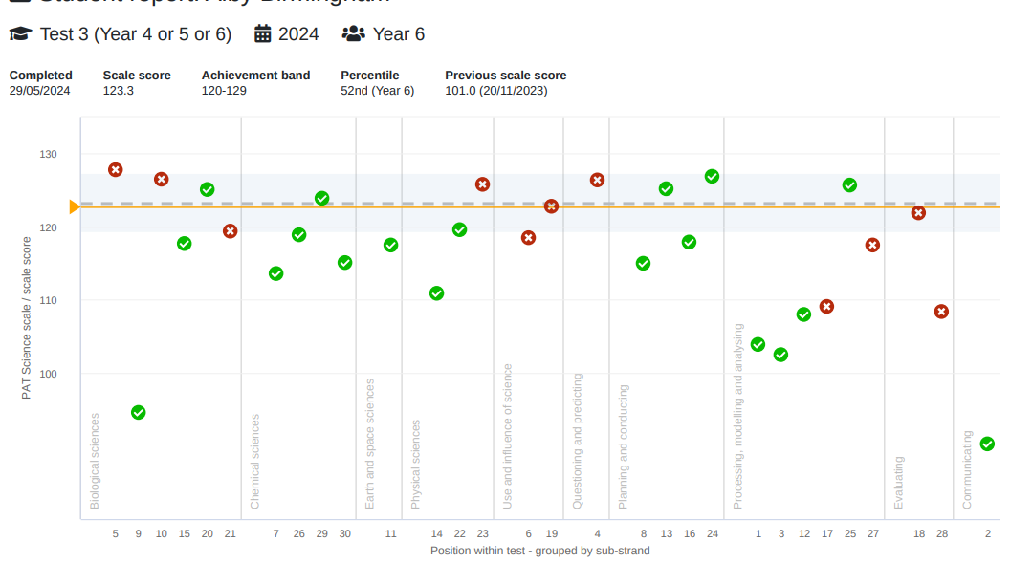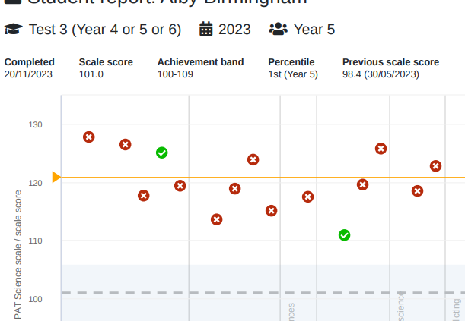

**REPORTING:**

Reporting is the process of communicating the outcomes of assessment to students, parents and carers.

School Expectations for Formal Reports

Classroom Teachers

Learning Area grades should be submitted along with agreed sub-strand grades. This will allow parents to know what area of the curriculum has been covered e.g. geography or History

Learning Area Comments: No longer required as per communication from *Department “Reporting Student Progress” 28/8/2024*

General comments: General comments should begin with a positive and end with an encouraging or celebratory comment. Comment on progress in English and Math as well as social skills, attitude to learning, effort and interests. May include any involvement in extra curricula activities.

Parent Interview

Invitations for Parent Interviews will be sent out to all parents for the last week of each semester. Relief provided to free teachers for these interviews. Application will be made to close the school

School Expectations for Formal Reports

Comments

* The student’s legal name must be on the title of the report however the preferred name may be used throughout as long as it is consistent. Please check Integris and confirm with parent / guardian if unsure.
* Generally, comments should be written to the parent/carer not the child however it is acceptable to write a positive statement to the student at the conclusion of the general comment.
* Use a variety of sentence starters, do not just alternate how you refer to the student at the beginning of a sentence and midsentence, e.g. name…pronoun…name…pronoun.
* Use language consistent with the WA Curriculum. English rather than literacy and Mathematics not numeracy.
* Do not predict future outcomes, e.g. I’m sure with more effort Jennifer will…
* Delete redundant words or sentences that do not change the meaning. For example, ‘a range of different ideas’ says no more than ‘a range of ideas’.
* Be objective rather than subjective. Use language that describes observable or measureable skills/ understandings/ behaviour.
* Remember to write to the audience. Don’t use jargon or generalise statements from planning documents.
* It is not possible to include comments on everything taught, identify aspects of achievement that are most important.

Conventions

Correct use of grammar, punctuation and spelling is essential. The following points highlight common errors.

* Apostrophes are not used for simple plurals or when abbreviating expressions or when referring to a number, e.g. skip counting by 2s.
* Capital letters are used in reference to:

* a particular school term or semester, e.g. Term Two or Semester One

* a particular year level of students, e.g. Year Three

* ‘ise’ or ’ize’ – The first spelling by the Macquarie Dictionary is used, that is

* realise

*organise

* recognise

* practise/practice – verb is ‘s’ and noun is ‘c’. (Jennifer needed more practice playing the flute so she went to music lessons to practise.)
* Numbers nine and under are written in words in texts and those above nine written as numerals.
* Do not use commas or spaces between each set of three digits for numbers between 1000 and 9999. Use a space, not a comma, for numbers 10 000 and greater.
* Hyphens are no longer used for cooperate, coordinate or online.
* Please use focused not focussed.
* Consult the Macquarie Dictionary if you are in any doubt about the correct spelling of a word.
* Use a single space after a full stop.

**2025 - IMPORTANT DATES FOR REPORTING**

*SEMESTER ONE*

**Week 1 Term 2** Reports checked by all teacher for access and content. Any errors to be reported to Neil by Friday.

**24h May** Reportsopen for data entry.

**13th June** Reports due for Admin checking.

**13th -17th June** Admin checking of reports.

**17th – 23rd June** Corrections/changes made**.**

**24th June** Reports printed.

**24th June** Principal to sign reports.

**25th June Reports sent home.**

**2nd July Parent Interview day**

*SEMESTER TWO*

**Week 1 Term 4** Reports checked by all teachers for access and content. Any errors to be reported to Neil by Friday.

**9th Nov** Reports open for data entry.

**28th Nov** Reports due for Admin checking**.**

**28th – 2nd Dec** Admin checking of reports

**2nd - 8th Dec** Corrections/changes made.

**9th Dec** Reports printed.

**9th Dec** Principal to sign reports.

**10th Dec Reports sent home.**

**15th Dec Parent Interview day**

|  |  |  |
| --- | --- | --- |
| **2024** | **Semester I** | **Semester II** |
| **English** | **Reading & Viewing**  **Writing**  **Speaking & Listening** | **Reading & Viewing**  **Writing**  **Speaking & Listening** |
| **Maths** | **Number & Algebra**  **Measurement &Geometry** | **Number & Algebra**  **Measurement &Geometry**  **Statistics & Probability** |
| **Science** | **Biological Sciences**  **Earth and Space Sciences** | **Chemical Sciences**  **Physical Sciences** |
| **HASS** | **History**  **Civics & Citizenship** | **Geography**  **Economics & Business** |
| **Health & PE** | **Personal, Social & Community**  **Movement & Physical Activity** | **Personal, Social & Community**  **Movement & Physical Activity** |
| **Design & Technology** | **Digital Technologies**  **Design & technology** | **Digital Technologies**  **Design & Technology** |
| **The Arts** | **Music** | **Visual** |
| **Languages -**  **Indonesian** | **Communicating** -Refer SIDE Policy | **Understanding** -Refer SIDE Policy |